* Zero overhead means you don’t have to pay for features you wont use
* Output/Input form
  + Cin<< //input
  + Cout>> //output
  + Pass in iostream and use namespace std
* Cerr=predefined output stream
* C++ always bool types
* Make sure you avoid over/underflow
* C++ references are aliases
* Most functions pass in inputs first then pass in outputs
* When wanted to pass in constants into c++, use const type &var
  + This to be more efficient as it is wasteful storing a read in value and storing it
  + Const makes sure the value is not changed
* Variables params, and functions are stores on a stack whereas dynamic memory is more permanent and outlast function calls from a memory heap
* We use new to store on the heap and delete to remove it
  + Form type *pointer = new type; delete p;
  + Set pointer value to nullptr to prevent access (avoid NULL/0)
  + Declaring an array dynamicallywith new is as follows:
    - Const type N = val;

Type *p = new type[N];

Delete []p;

* All new and delete keywords must be paired up. Valgrind used ot make sure of this
* Call by Value vs ref
  + Call-by-Value  
    + Callee detached from caller, no direct side effects  
    −Data is copied to a local variable. Can be time consuming
  + Call-by-Reference  
    −Possible side effects, need to look at function declaration to see whether call-by-reference is used  
    E.g. foo(x) doesn’t tell you whether foo’s parameter  
    is int or int&  
    + Only reference is copied. Fast - internally it’s just a  
    pointer
* Default args must always be put as the last parameter in function names
* ADT(Abstract Data Types)=Struct + Global Functions
  + Struct Form :
    - struct Point  
      {  
      int x, y;  
      };  
      struct Point p; // define point variable p  
      p.x = p.y = 0;
* Structs are special cases of classes in that they don’t impose overhead runtime, not initialized and require clean-up and initialization
* Classes have methods, auto clean-up and initialization, can restrict access. They also allow for inheritance and multiple inheritance. These are made up of Data and Methods
  + Form is class name{public: … private …}
* They can contain public and private methods.
  + Pubic: Data/method accessible to all methods and owner
  + Private: Only accessible to methods
  + Protected: Same as private but is mainly used for inheritance
* Methods mainly in class body and these at on data members of the class
  + Also be used outside of class if public
* Struct X{…} == class X {public:…}
* Best to use a header file to initialize the methods of a class and use the cpp file to type out its functionality
* Most data members are private
* Constructors is used to create the class in question and its variables are automatically initialized by this function. Also allocates memory on heap/stack
  + Usually indicated by the class_name(params) inside the class
* Destructors are methods that clean up the class at the end and de-allocate memory. Called when class variable leaves scope/deleted.
  + Appears as ~class_name() inside the class
  + Note if this is not defined, there is a default destructor being used
* Copy Constructor is initializing a new class and copy the content of passed in class to it.
  + Form is: Foo(const Foo &rhs) {}// where rhs is the struct whose contents you wish to copy
  + Foo b(a) creates a new struct b where it has the same contents of a
  + Copies POD members bitwise and can call CCs for non-POD members
  + Pointers are also copied so the two objects can share the same pointer
* Assignment Operator is the same as a CC but instead of creating a new object, an existing object is used
  + Foo u
  + Foo w=u, Copies contents of u into w
  + Foo &operator= (const Foo &rhs)  
    {  
    u = rhs.u; // for POD members, just copy bitwise  
    return *this; // returns a reference to the lhs object  
    }
  + This is a pointer whereas *this is refers to the actual object
  + Default AO does member-by-member copy
  + BY returning a reference to an object, we can chain assignments together
  + ALWAYS check if we are copying the same object to guard against self assignment
    - if (this == &rhs) { // self-assignment,  
      return *this; // nothing to do!  
      }
* Shallow Copy: Copies bits in case of POD members
* Deep Copy: Copy data that pointer points to recursively
* When we have a pointer member we always want a destructor to free that memory created in constructor
* CC tend to include the code of the constructor but copy bitwise
* Constructor initializing list. Usually appear after a : in the function name. They appear as z(_z) where we initialize z with the passed in z_
* If we include =delete after functions, we can make the inaccessible
* Class Inheritance: Derive new class from an existing class
* Code Adaptation/data re-use
* Single Inheritance: Inheritance from 1 class
* Multiple Inheritance: Inheritance from 2+ base classes
* Think of Inheritance as a is-a relationship
  + B is a A , B is derived from A, B is a subclass of A, A is a superclass of B, A🡨 B
* Mathematical set inclusion does not imply an is-a relationship
  + Circle-Eclipse Problem: If we stretch a circle in the x/y direction, they could lose identity due to distortion be becoming an ellipsis whereas it wouldn’t affect an ellipse.
* Example of Inheritance
  + // base-class  
    class Shape  
    {  
    public:  
    // all shapes have a color  
    int color;  
    // and area function  
    // default implementation: return 0  
    float area() const { return 0; }  
    };  
    // first specialized shape: axis aligned rectangle  
    class Rectangle : public Shape  
    {  
    public:  
    // constructor: 4 values define a rectangle ...  
    Rectangle(int l_, int r_, int t_, int b_) { ... }  
    // overrides Shape::area()  
    float area() const { return (r-l)*(b-t); }  
    private:  
    // describes Rectangle (left,right,top,bottom)  
    // also inherits color  
    int l, r, t, b;  
    }
  + As rectangle is derived from shape it contains all the members as shape does
* Derived class inherits all data members and methods from base classes
* Access permissions generally depend on qualifiers
  + Subclasses can access public and protected methods but can not access private methods
  + Form: class Y: public/protected X {}
* Subclass data members added at the end of baseclass data
  + Allows us to treat subclass objects as baseclass objects
* If equating, make sure it is in the form base-class=subclass
  + While we are losing info, it still works a all of the members of base-class in sub-class are copied
  + We can also use pointers for this,
    - class Y : public X {...};  
      X a, *pa;  
      Y b, *pb;  
      pa = &b; or pa = pb;
* Base class operators need to be explicitly called when you use your own implementation in derived class
  + truct X  
    {  
    X() { x = 0; }  
    int x;  
    };  
    struct Y : public X  
    {  
    Y() { y = 0; }  
    Y(const Y &rhs)  
    : X(rhs), y(rhs.y) // copy-construct X part and Y part  
    { // ^---- base-class name  
    }  
    Y &operator=(const Y &rhs)  
    {  
    if (&rhs == this) return *this; // guard against self-assignment  
    X::operator=(rhs); // call X AO, assigns X part  
    y = rhs.y; // assign Y-part  
    return *this;  
    }  
    int y;  
    };  
    X a, *pa;  
    Y b;  
    a = b; // a.x = b.x; b.y not copied (object slicing)  
    pa = &b; // OK, *pa is object of type X. Y part invisible
* Derived class constructor calls base-class constructor first to initialize base-class members
  + If none defined, dfault derived one will be provided which calls the base-class and constructs non POD members for subclass
    - Eg
  + class X  
    {  
    public:  
    X(int a_=0) { ... }  
    };  
    class Y : public X  
    {  
    public:  
    Y() { /* X() is called here */ ... }  
    Y(int b) : X(b) { ... } // explicit X(int) call  
    }
* Destructors called in reverse order of constructor calls
  + struct X  
    {  
    X() { p = new int[100]; }  
    ~X() { delete [] p; }  
    int *p;  
    };  
    struct Y : public X  
    {  
    Y() { /*X() called here*/ q = new int[200]; }  
    ~Y() { delete [] q; /* ~X() called here*/ }  
    int *q;  
    };
  + Derives class destructor Y calls base class destructor,
  + Y() deals with resources allocated in Y while X() is called at end and takes care of rest
* Virtual Functions
  + Polymorphism: Same function name but actions change depending on object type
    - Objects need to know their type so we use virtual functions
  + Virtual keyword indicates method in subclass which is accessible via base-class pointers
  + E.g :
    - / abstract base-class  
      // (because it contains abstract functions)  
      class Shape  
      {  
      public:  
      int color;  
      // =0: marks abstract methods  
      // derived classes must implement them  
      virtual void draw(Screen *s) const = 0;  
      virtual float area() const = 0;  
      };  
      class Circle : public Shape  
      {  
      public:  
      ...  
      void draw(Screen *s) const { ... }  
      // draws circle, implements virtual function  
      };
* When there are virtual functions, the compiler adds an extra data member to class which is the virtual function table pointer(VFTP). This points to a block of memory containing info about class type
* There is usually one VFT for each class type in program and these give access to type info.
* Can store function addresses in pointers
  + Form: void foo(int x) { }  
    void (*p)(int);  
    p = &foo;  
    (*p)(5); // calls foo(5)
* Using Virtual functions creates runtime costs while not using them doesn’t
* If using virtual functions, destructors must also be virtual
  + Example :
    - class Shape  
      {  
      public:  
      virtual void draw(Screen *s) = 0; // abstract  
      virtual ~Shape() { } // do nothing  
      };  
      class Circle : public Shape { ... };  
      class Rectangle : public Shape { ... };  
      class Square : public Shape { ... };  
      {  
      const int N = 3;  
      Shape *A[N];  
      // allocate shapes (constructor arguments omitted)  
      A[0] = new Circle; A[1] = new Rectangle; A[2] = new Square;  
      // draw all shapes using their respective draw functions  
      for (int i=0; i < N; ++i) {  
      A[i]->draw(screen);  
      }  
      // delete all shapes using their respective destructors  
      for (int i=0; i < N; ++i) {  
      delete A[i];  
      }  
      // Important: the destructor loop above is needed, because pointers  
      // are POD and when arrays go out of scope, element destructors are  
      // not called!  
      // When in doubt, simply ask yourself when typing new ... where the  
      // corresponding delete is  
      }
* To override methods from baseclass:
  + Base class function must be virtual
  + Based & derived function names must be identical except for destructors
  + Parameter types and constness must be identical
  + Return types and exception specifications must be compatible
* Using the keyword override we can do this as long as all above conditions are met
* The keyword final specifies that a function can’t be overridden
* Make sure you don’t call virtual functions in constructors
* virtual function calls in base-class constructors call base-class functions! Derived class functions can’t be called this way, because the derived class object hasn’t been fully constructed yet.
* Type Casts
  + Casting ops disable compiler check
  + Major port issues
  + C++ uses long keywords to make one avoid this
* Static_cast is used for numerical conversions. They have no run-time check and should not be used for pointer up/down casts
  + Form E.g.:
    - int i;  
      double d;  
      i = static_cast<int>(d);  
      // same as i = (int)d; (rounds towards 0
* Reinterpret_cast allows us to change one pointer type to another. However issues can arise
  + Can give us byte level access
  + E.g.s:
    - int a[100];  
      // char *p = a; doesn’t work: type error  
      char *p = reinterpret_cast<char*>(a);  
      // get direct access to 400 bytes
    - int x;  
      char *p = reinterpret_cast<char*>(&x);  
      // write low byte first  
      if (little_endian_machine) {  
      for (int i=0; i < sizeof(x); ++i) write_byte(p[i]);  
      } else {  
      for (int i=sizeof(X)-1; i >= 0; --i) write_byte(p[i]);

//Saves an integer into a file in such a way that it is portable with the assumption sizeof(x) is identical.

* Const_cast toggles whether a function is const or non-const
  + Mutable keyword is better
  + Const_cast e.g. :
    - lass X  
      {  
      public:  
      int get_index() const  
      {  
      // increment counter,  
      // preserve constness  
      // ++get_n; doesn’t work because get_index is const  
      ++const_cast<X*>(this)->getn;  
      ...  
      }  
      private:  
      int get_n; // how often was get_index called?  
      }
  + Mutable example:
    - class X  
      {  
      public:  
      int get_index() const  
      {  
      // increment counter  
      // allowed because get_n is mutable  
      ++get_n;  
      ...  
      }  
      private:  
      mutable int get_n;  
      };
* dynamic_cast allows one to go up and down the type hierarchy:
  + E.g. :  
    - struct X {  
      virtual void foo(); // makes X polymorphic  
      };  
      class Y : public X { };  
      ...  
      X *px = new X;  
      Y *py = new Y;  
      // failed down-cast  
      // effect: pxy = nullptr, because Xs are no Ys  
      Y *pxy = dynamic_cast<Y*>(px);  
      // successful up-cast  
      // effect: pxy != nullptr pointing to X component  
      // because Ys are Xs  
      // At this point, the cast never fails  
      // because py points to a Y  
      X *pyx = dynamic_cast<X*>(py);  
      X *pyx = py; // this is equivalent
  + Useful for downcasting pointers but can often be misused so use virtual functions instead
  + Non-trivial runtime check
  + Source must be polymorphic
  + Returns 0 if illegal or a object pointer if valid
* Static:
  + E.g.
    - static void foo() { }  
      // this defines a helper function local to Foo.cpp  
      // which is not accessible in other .cpp files  
      void bar()  
      {  
      static X x;  
      // Object x is a persistent *global* variable which is  
      // constructed when bar is executed for the first time.  
      // Such static construction is thread-safe (which means  
      // that multiple execution threads can call function bar  
      // simultaneously) and static objects are destroyed in  
      // reverse order of their construction.  
      }
  + As C++ doesn’t define well how the order of global objects’ initialization well , wrap global objects into access function so we can decide when to init them.
    - E.g.:
      * struct X  
        {  
        X() { a = 0; }  
        int a;  
        };  
        X &get_x()  
        {  
        static X x; // x constructed during first call  
        return x; // reused thereafter  
        }  
        int main()  
        {  
        get_x().a = 0; // create static object, set a  
        cout << get_x().a << endl; // use object  
        }
  + Static in class context
    - Useful if every object can access the same viable/counter to know how many objects have been called.
      * Saves space
      * Hiding info is enforced as static variables can be private
      * Not in global name space
      * Eg:
        + class X  
          {  
          public:  
          X() { ++count; ... }  
          ~X() { --count; ... }  
          // static member function  
          static int get_count() { return count; }  
          private:  
          // number of X objects, shared by all X objects  
          static int count;  
          };  
          // must be defined in file X.cpp!  
          int X::count = 0;  
          int main()  
          {  
          X a, b;  
          cout << X::get_count() << endl;  
          // output 2; note that we don’t need an object  
          // to call get_count --- it’s a global function  
          // in class X  
          return 0;
* Operator Overloading:
  + Our end goal is to define what operators do when they are applied to our classes
  + C++ allows us to redefine operators(global and class)
  + Following three can not be changed:
    - Arity(No of params)
    - Associativity(Left/Right)
    - Operator precedence
  + Recall post/prefix operator: e.g. i++ ++i
  + :: has highest priority while , is the lowest
  + Use brackets to force the ops you want to do rather than worry about precedence
  + E.g.:
    - // defines class that represents complex numbers  
      // (essentially points in 2d defining the number  
      // field complex analysis is concerned with)  
      #include "Complex.h"  
      int main()  
      {  
      Complex a(1.0);  
      Complex b(0.0, 1.0);  
      Complex c;  
      // arithmetic using points rather than scalars  
      c = (a + b) * (a - b);  
      c += Complex(4, 3);  
      c = c + 3.0; // shorthand for + (3.0, 0.0)  
      ++c; // means c = c + (1.0, 0)  
      std::cout << c << std::endl; // prints 8 3  
      };
  + To define global ops; use the following example(done for >> <<):
    - stream &operator<< (ostream &os, const X &rhs);  
      istream &operator>> (istream &is, X &rhs);
  + This allows us to return a reference to streams which allow chaining such as :
    - cout << x << y;  
      cin >> x >> y;
  + E.g. :
    - class Complex  
      {  
      public: ...  
      // gives functions access to private members  
      friend ostream &operator<<(ostream &os, const Complex &rhs);  
      friend istream &operator>>(istream &is, Complex &rhs);  
      private:  
      float re, im;  
      };  
      ostream &operator<< (ostream &os, const Complex &rhs)  
      {  
      os << rhs.re << ’ ’ << rhs.im;  
      // Alternative:  
      // os << rhs.get_re() << ’ ’ << rhs.get_im();  
      return os;  
      }  
      istream &operator>> (istream &is, Complex &rhs)  
      {  
      is >> rhs.re >> rhs.im;  
      // Alternative: float u; is >> u; rhs.set_re(u); is >> u; rhs.set_im(u);  
      return is;  
      }  
      // application  
      Complex a;  
      cin >> a; cout << a;
  + the keyword friend allow us to access private members
* Class ops,
  + These are considered methods which can be invoked when lhs is an object and rhs is another object/POD, or when unary arg is an object. That means the compiler will rewrite ops into member function class. E.g.:
    - a + b -> a.operator+(b)  
      a += b -> a.operator+=(b)  
      v[2*i+1] -> v.operator[](2*i+1)  
      f(x, y) -> f.operator()(x, y)  
      // f is called a "functor",  
      // looks like a regular function call  
      ++x -> x.operator++()  
      x++ -> x.operator++(0)  
      // 0 is a dummy parameter indicating post increment
  + Note:
    - Type Operator++(){} defines prefix ++ and Type Operator++(int) defines postfix ++.
  + Class ops can act as member functions so you can make it virtual
    - [] supports one arg and () supports any num of args.
  + We can creates objects that behaves like an array/function.
  + This also means type cast ops can be modified:
    - class Rational  
      {  
      operator double() { return (double)num / double(den); }  
      };  
      Rational r;  
      cout << static_cast<double>(r) << endl;  
      // calls operator double()
  + E.g. 2 dealing with int vectors:
    - class V  
      {  
      public:  
      ...  
      // returns reference so that elements can be changed  
      int &operator[](int i) {  
      check(i);  
      return p[i];  
      }  
      // const version  
      const int &operator[](int i) const  
      {  
      check(i);  
      return p[i];  
      }  
      ...  
      private:  
      void check(int i) const { assert(i >= 0 && i < n); }  
      int *p;  
      int n;  
      };  
      in main():  
      V v(100);  
      v[3] = 0; cout << v[0]; // cool! vectors act like arrays
  + Complex Number example revisited:
    - class Complex // Complex Number class  
      {  
      public:  
      Complex(float r=0, float i=0) : re(r), im(i) {}  
      // use default destructor; default CC+AO also work  
      Complex operator+(const Complex &rhs) const;  
      Complex operator+(float rhs) const; // add float  
      ...  
      Complex &operator+=(const Complex &rhs);  
      Complex &operator+=(float rhs); // add float  
      ...  
      Complex &operator++(); // pre++ (++c)  
      Complex operator++(int); // post++ (c++)  
      Complex operator-() const; // unary operator  
      ...  
      float real() const { return re; } // gives environment  
      float imag() const { return im; } // access to data  
      private:  
      float re, im; // real & imaginary part  
      }
    - To use the above we need global ops such as (complex operator+(double lhs, const Complex &rhs); to deal with asymmetries such as Complex a,b; a= 2.0 +b as those cant be handled by class ops as LHS isn’t a struct.
    - Recall there is a difference between i++ and ++i
    - E.g.
      * Cout<<i++ when i=5 prints 5 then increments whereas cout<<++i increments I and then prints
      * Therefore i++++ is illegal whereas ++++I isn’t as it returns a refence to i
    - Postfix is generally slower as they need to store the value of object prior to incrementing and return the copy.
* OP overloading tips
  + Similar ops must do similar actions
  + Use reference parameters whenever you can and return when you must
  + Avoid complex expressions with side-effects
  + Split up expressions into smaller expressions which works alongside the ; as it marks a sequence point.
  + DO NOT OVERLOAD && & || ,
* Code independent of actual types(e.g. sorting routines and containers)
* We use generic programming due to it being easy to maintain and reuse code-blocks
* We do this via function templates
  + C++: sort(v.begin(), v.end(), Compare());
  + Short and faster, allows compiler to inline code
* Function Templates
  + NO need to define long lists
  + Below form tends to conver almost all function templates
  + template <typename T>  
    T min(T a, T b) {  
    return a < b ? a : b;  
    }
  + Min is now parameterized by Type T and will assume < is defined by type T
  + E.g.
    - template <typename T>  
      T max(T a, T b)  
      {  
      return a > b ? a : b;  
      }  
      template <typename T>  
      void swap(T &a, T &b)  
      {  
      T temp(a); a = b; b = temp;  
      }  
      int main()  
      {  
      int a = 10, b = 5, c = max(a,b); // calls max<int,int>  
      float e = 2.0, f = 1.0, g = max(e,f); // max<float,float>  
      swap(a, b); // swap<int, int>  
      swap(e, f); // swap<float, float>  
      }
    - Assumes CC AO are made
    - emplate <typename T>  
      T max(T a, T b);  
      // OK, forward declaration; eventually,  
      //code needs to be provided in header file  
      template <typename T>  
      void swap(T &a, T &b);  
      // OK, forward declaration; eventually,  
      // code needs to be provided in header file  
      template <typename U, typename V>  
      U foo(U a, V b)  
      {  
      return a;  
      }  
      // OK, class/typename are synonyms  
      // U,V appear in function signature  
      template <typename U, V>  
      U bar(V a);  
      // ERROR: no typename/class in front of V  
      // PROBLEM: when calling bar(x) compiler cannot  
      // infer type U => need to write bar<int>(a)  
      // compiler infers U=int
  + Function templates specify how individual functions can be constructed given set of types
  + Tends to happen as a side effect of either invoking or taking address of function template
  + Compiler removes identical instantiations and as template instantiation is slow, the compiler will complain
* Type Parameter Binding
  + E.g.
    - template <typename T>  
      T max(const T* a, int size)  
      {  
      ...  
      }  
      float a[100], x; ... x = max(a, 100);  
      // formal parameter: const T *a -> T *a  
      // actual parameter: float *a => T = float
    - Each argument of function template is examined for presence of formal type parameter
    - If formal type parameter is found, type of corresponding argument is determined
    - Types of formal and actual args are matched. Type qualifier ref, const and volatile are ignored therefore safer
* Macro vs Function templates:
  + Function templates are type aware but Macros aren’t
  + Function templates can be specialized early whereas Macro can’t
  + Inlined function templates are fast as macro generated codde
  + No Unwanted side effects with function tmplates whereas macro parameters may be evaluated more than once
  + Comparison code:
    - #define min(a,b) ((a) < (b) ? (a) : (b))  
      // vs.  
      template <typename T>  
      T min(const T a, const T b)  
      {  
      return a < b ? a : b;  
      }CMPUT 350, F2021, M. Buro Function Templates 10  
      #define array_size_macro(A) (sizeof(A)/sizeof(A[0]))  
      // vs.  
      template <typename T, std::size_t n>  
      constexpr std::size_t array_size(const T (&A)[n])  
      // note that we pass a reference to an array  
      // otherwise, size information is lost as arrays  
      // are then treated as pointers  
      {  
      return n;  
      }  
      ...  
      int A[10];  
      cout << array_size(A) << endl; // 10  
      int B[array_size(A)]; // works  
      int *i;  
      cout << array_size_macro(i) << endl; // shouldn’t!
* Class Templates:
  + Reuse type independent code and classes are parameterized by types
  + Syntax:
    - template <typename T>  
      class X  
      {  
      ... T can be used here ...  
      }
    - Note that int and bool can be used as template parameters
  + Useful for container types like vector, set and lists whose code isn’t reliant on types of value stored in them
  + Class template instantiation is explicit whereas function template instantiation is implicit but can occasionally be implicit
  + Compiler instantiates class templated on demand
    - Formal type parameters get replaced by actual parameters and those be done in the header file
  + E.g. Stack Class Template:
    - template <typename T>  
      class Stack  
      {  
      public:  
      Stack();  
      ~Stack();  
      // Stack is a container class =>  
      // method code independent of T  
      void push_back(T &v) {...} // append element  
      T &back() {...} // last element (if !empty)  
      void pop_back() {...} // remove last  
      bool empty() const {...} // true iff empty  
      private:  
      T *p; // implemented using dynamic array  
      int size;  
      };  
      Stack<int> si; // int stack  
      Stack<float> sf; // float stack  
      si.push_back(5);  
      cout << si.back();  
      if (si.empty()) exit(0);  
      sf.push_back(3.5); ...
  + When compiler sees Stack,int. si, it compiles stack as T=int and can manipulate it without needing to compile it several times. The same occurs for float
* Class Templates tend to be instantiated for multiple types on demand in each cpp causing to more work
* We HAVE to clarify if an identifier is a type or not:
  + E.g. :
    - template <typename T>  
      class X  
      {  
      typename T::SubType *ptr;  
      }
  + Without the type name, subtype is considered static causing it to be a multiplication with ptr rather than being a pointer variable
  + Using a name x by itself is not equivalent to this🡪c despite being inherited so we we have to use this🡪function orX<T>::function.
  + We can specialize class templates to adapt so special needs
    - template <> class X<type you want> { ... }
  + const char *min(const char *a, const char *b) {  
    return strcmp(a, b) < 0 ? a : b;  
    }
    - Fixes code as an unexpected issue would occur
* Partial class template specialization:
  + // (A) general case  
    template <typename T>  
    class List { ... };  
    // (B) special case where we handle pointers  
    // to types: share void* implementation and  
    // use pointer casts ...  
    template <typename T>  
    class List<T*> {  
    List<void*> impl; // infinite recursion?!  
    ...  
    T* get(int i) const {  
    return reinterpret_cast<T*>(impl.get(i));  
    }  
    };  
    // (C) if we don’t provide this, we run into an  
    // infinite recursion at compile-time:  
    template <> class List<void*> { ... };  
    List<int> x; // instantiates (A)  
    List<int*> y; // instantiates (B)  
    List<void*> z; // instantiates (C)
  + Compiler looks for best (= most specialized) type match
  + For pointer types we only fully instantiate List<void*>  
    once
  + All other List<T*> classes are just wrappers which
  + delegate method calls to impl
  + Partial class template specialization adapts class templates even more
  + Compiler chooses the most specialized match
* We occasionally want to know types at compile time. We infer properties at compile time via compile-time type reflection.
  + E.g.
    - template <typename T>  
      struct TypeTraits  
      {  
      // general case  
      template <typename U>  
      struct PointerTraits  
      {  
      enum { value = 0 }; // no pointer  
      };  
      // special case  
      template <typename U>  
      struct PointerTraits<U*>  
      {  
      enum { value = 1 }; // is pointer  
      };  
      enum { is_pointer = PointerTraits<T>::value };  
      // other interesting type properties ...  
      enum { is_reference = ... };  
      enum { is_const = ... };  
      enum { has_trivial_assign = ... }; // bit-wise copy OK?  
      };
  + In example above, enums are initialized with result of recursive compile time computation
* Fast memcpy function can copy arrays with POD objects otherwise we iterate through all element arrays
  + i.e. copy(b,a,N) where a and b are arrays and N is number of elements
  + template <typename T>  
    void copy(T *dst, T *src, int n)  
    {  
    CopyImpl<has_triv_assign<T>::value>::copy(dst, src, n);  
    // ***** 0: slow, 1: fast  
    }
* Having no trivial assignment is default
* If we do recursion at compile time, it can take a very long time despite speeding up runtime computation
* Boost is a community available C++ library which could make it into standard library(shared_ptr & type_traits)
* C++ arrays are better than C arrays
  + #include <array>
  + Treat similar to standard arrays in python
* We can convert numbers into strings and vice versa via include <ssrtream>
  + #include <sstream>  
    istringstream is("9999");  
    int n;  
    is >> n; // converts string into integer  
    if (!is) { ... failed ... }  
    ostrstream os;  
    os << n;  
    ... os.c_str() ... // string representing n
* If we use boost::lexical_cast is much faster and better
* STL=Standard Template Library
  + These contain:
    - Sequence Containers(elements with a pre-defined location) like vectors, list, slist deque and strings
    - Associative containers(elements dependent on a key) like set, map
    - Algorithms like sort find merge shuffle
    - Iterators: Pointer like types to traverse STL containers and iterastors between algorithms and containers
* For sequence containers, user specifies each element location and elements can be inserted/removed by indicating said location. (associative containers on the other hand store elements based on key)
* Vector:
  + Dynamic array functionality
  + Has type T list<T>
  + Doubly linked list template
  + Data associated with node is T
  + Must include <vector>
  + Compatible with arrays
  + Can grow and shrink
  + Elements laid out consecutively in memory and accessible by index
  + Linear time for insertion/removal
  + Methods:
  + 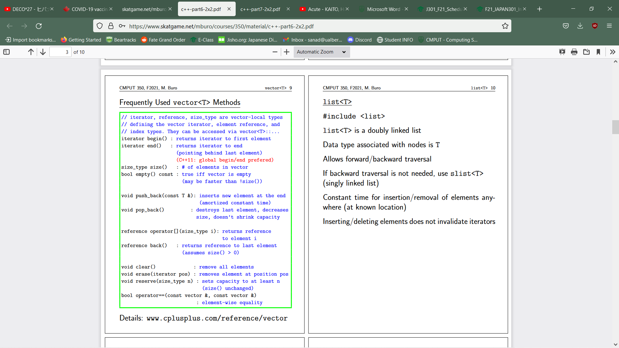
* List:
  + #include <list>
  + Doubly linked list
  + Type of list<T>
  + Allows forward/backward traversal
    - If not using backward traversal use slist
  + Constant time for insertion/removal
  + Inserting/deleting elements does not invalidate iterators
  + Methods:
  + 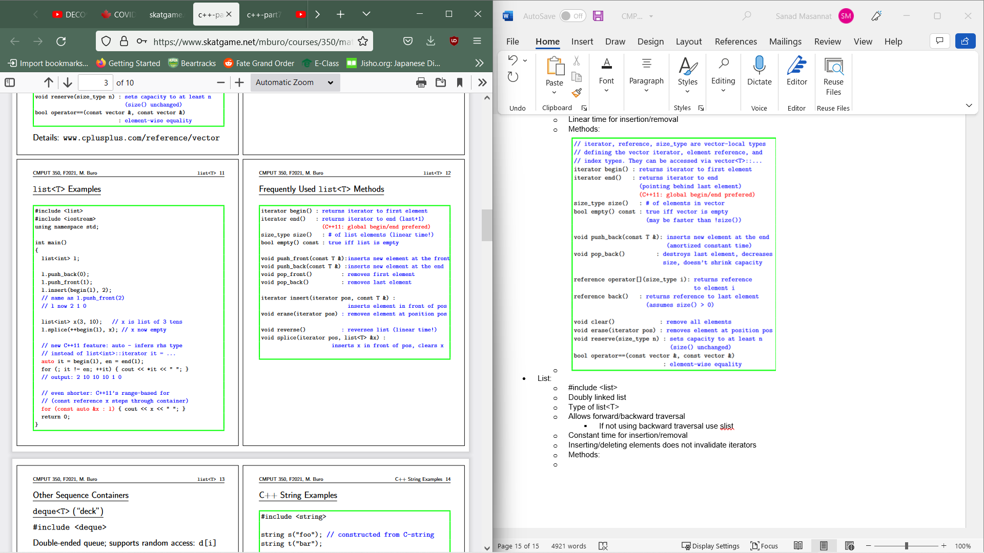
* Deque
  + #include <deque>
  + Double ended queue and supports random access
  + Inserting/deleting at ends take amortized constant time while middle takes constant time
* Basic_string<T>
  + Include string
  + Sequence of chars
  + Similar to vector
  + Lots of member functions like insert append ease and find
* Associative containers retrieve elements via keys/insertion and deletion
  + We can’t insert at specific locations
  + Keys can’t be modified but data can via iterators
* Set<T>
  + Keys unique to themselves
  + No elements are the same
  + Represented ad binary search trees internally
  + Log time for find/insert/delete
  + 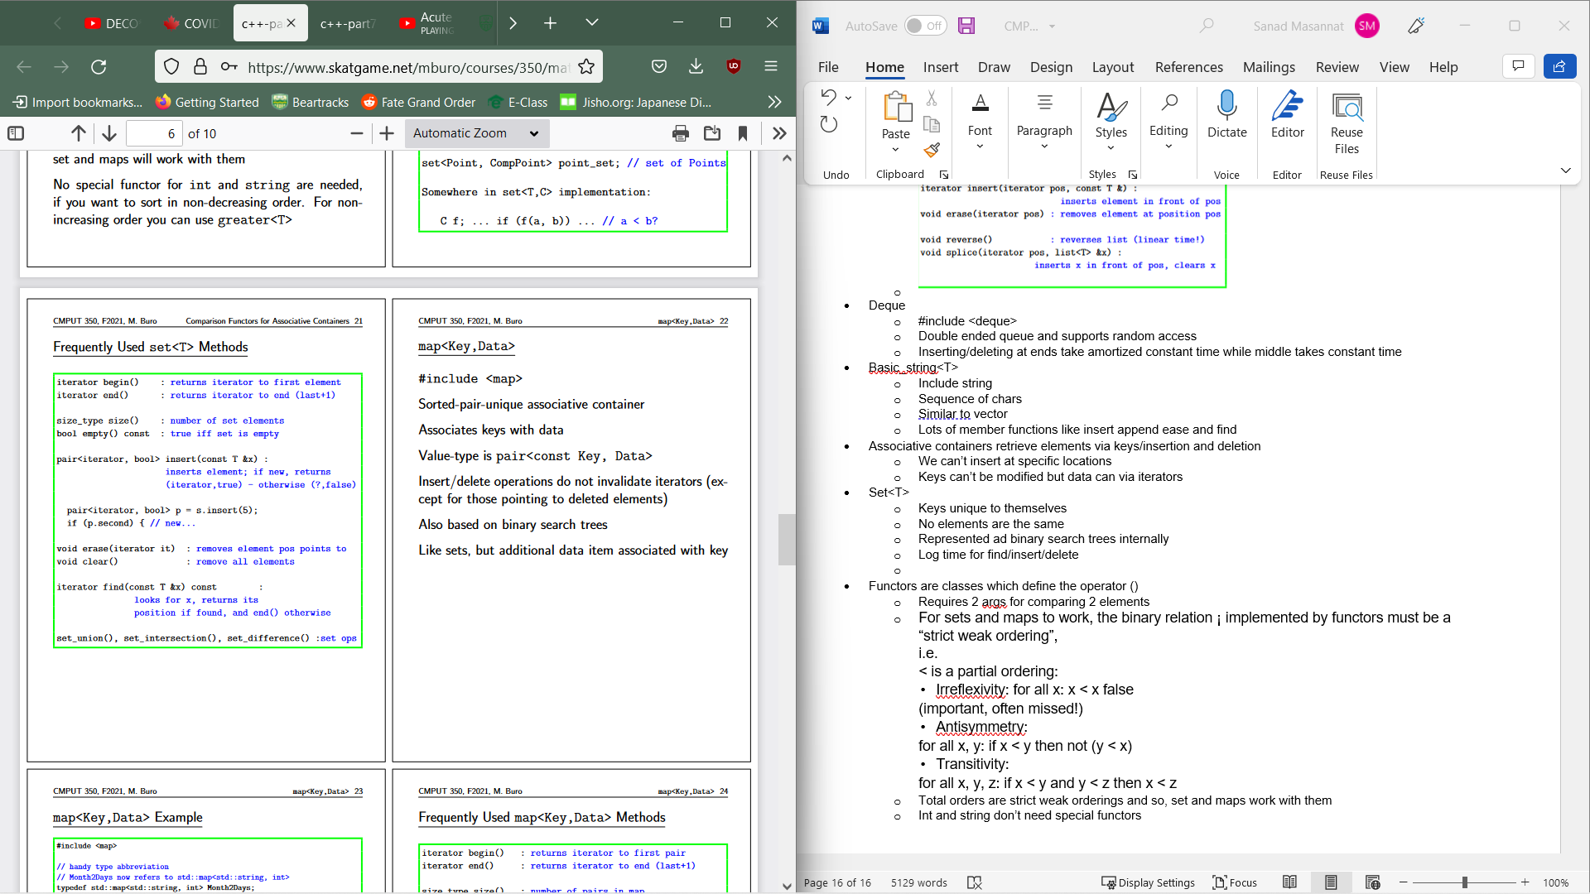
* Functors are classes which define the operator ()
  + Requires 2 args for comparing 2 elements
  + For sets and maps to work, the binary relation ¡ implemented by functors must be a “strict weak ordering”,  
    i.e.  
    < is a partial ordering:  
    • Irreflexivity: for all x: x < x false  
    (important, often missed!)  
    • Antisymmetry:  
    for all x, y: if x < y then not (y < x)  
    • Transitivity:  
    for all x, y, z: if x < y and y < z then x < z
  + Total orders are strict weak orderings and so, set and maps work with them
  + Int and string don’t need special functors
* Map<key,data>
  + Sorted-pair unique associative container
  + Value is pair<const Key, Data>
  + Insert/delete don’t invalidate iterators
  + BST based
  + 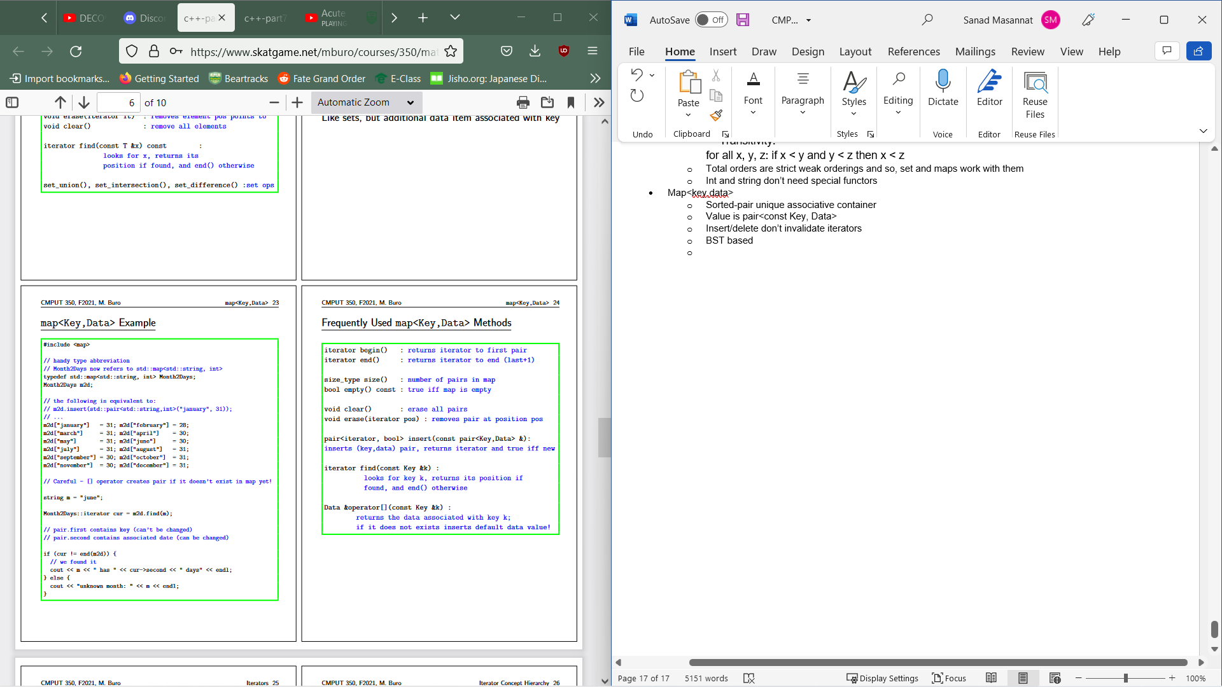
* Iterators are generalization of pointers and used to iterate over a range of objects
  + Iterator points to object and incrementations makes it point to next object
  + Used in generic programming
  + Algs take iterators as args
  + Container must provide a way to access its elements via iterators
  + Input/output iterator
    - Only single pass: v=*it
  + Forward iterator:++ only wherea bidirectional allows for both - - and ++
  + Random Access iterator
* Begin/end are used often to express range of operators(if begin()==end 🡪 range is 0)
  + End is used for indicating failures
* Const_iterator allows us to access const containers
* Reverse_iterators allows backward traversal
* Non-Mutating STLallows work on ranges without changing elements
  + 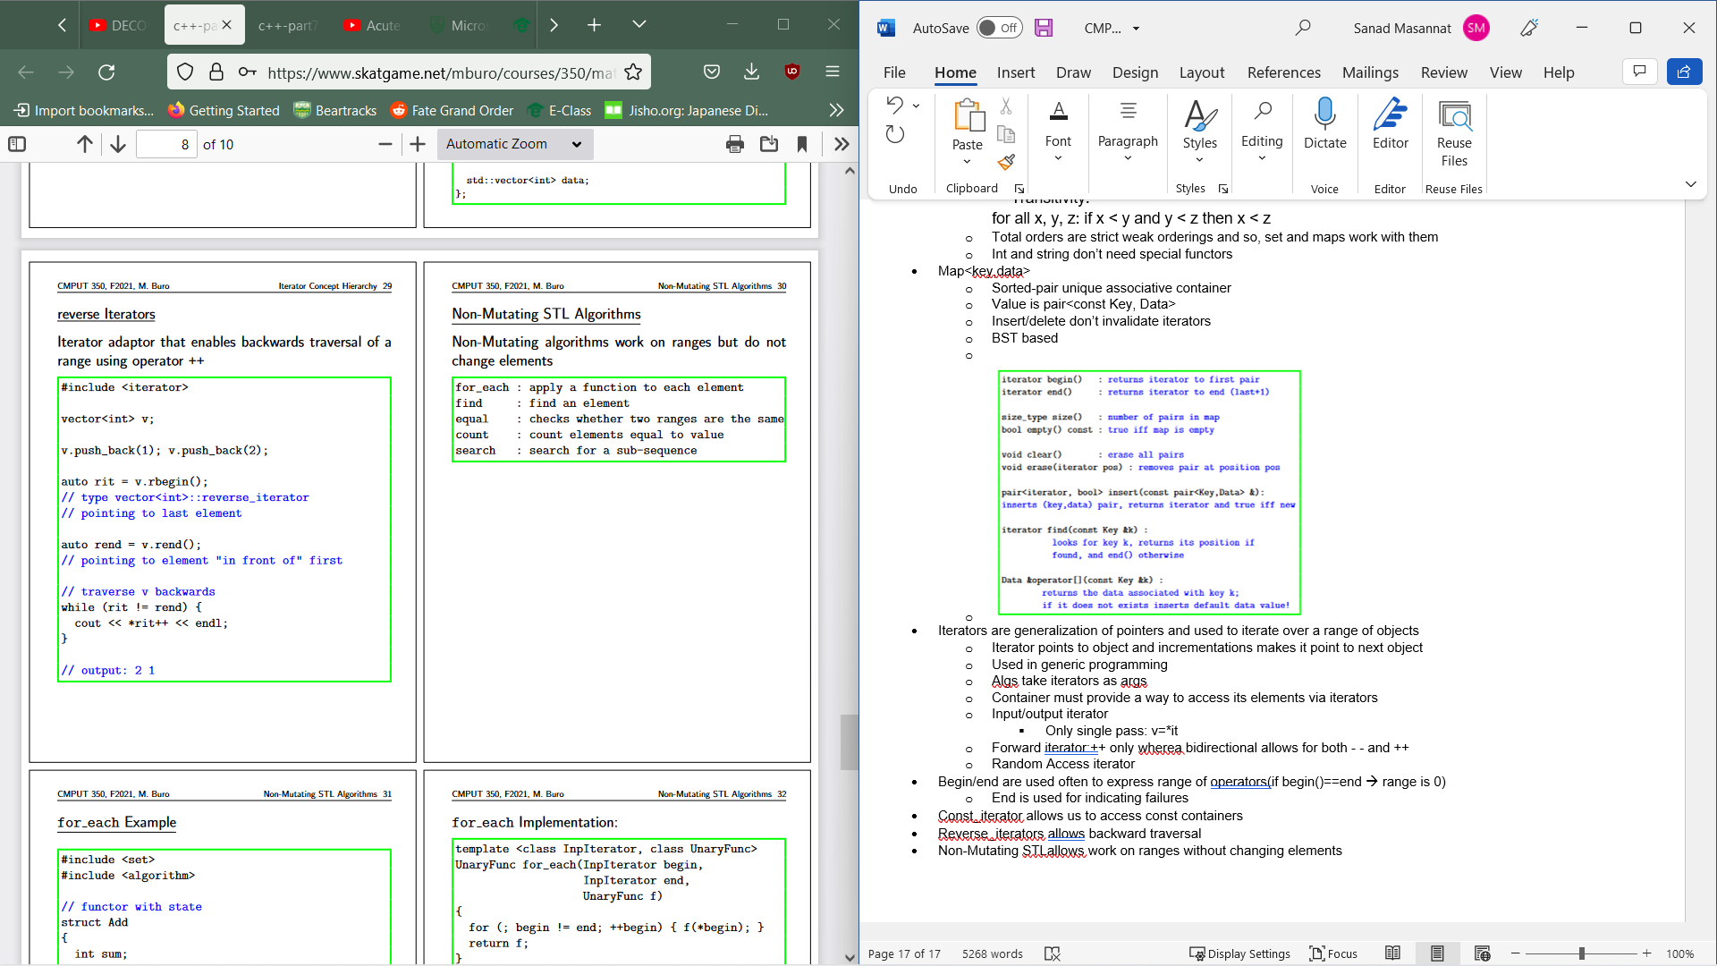
* Mutating STL works on range and could possible change elements
  + 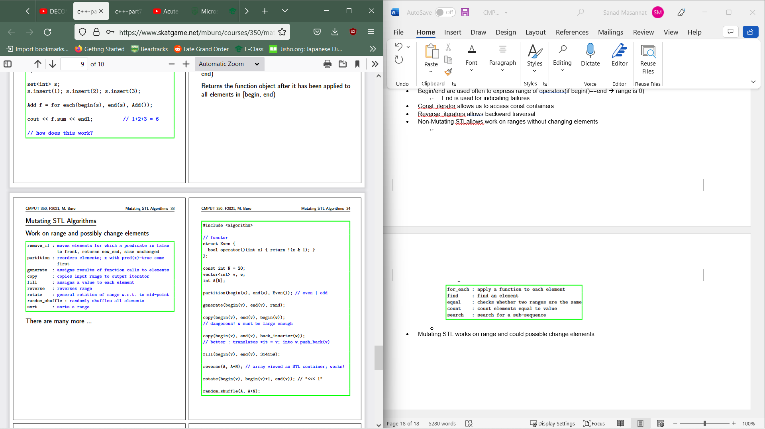
  + Sorts random access range in non-decreasing order and is fast
* Exceptions are code that deal with rare error conditions
  + Handled in a try block with a catch statement to handle the exception
  + Form:
    - Try{} catch(exception &e){};
* When an exception is thrown, program execution will stop then the system looks for next catch statement of compatible type with thrown value
  + If the exception was thrown in a try block, the following catch statements are checked  
    • If there is no match, the search for an exception  
    handler resumes in the caller (“stack unwinding”)  
    after all local objects have been destroyed  
    • If no matching catch statement is found, the program is aborted by calling std::terminate()
* When match is found, execution resumes there and at the end of the catch block, the thrown object is destroyed
* If the noexcept keyword is there, function is not allowed to throw anything
* The order of the catch blocks are important, it will stop at the first matching exception type
* Catch exceptions by reference as with pointers, we will not know whether to delete or not, whereas by value, splicing can occur.
  + This is expensive
* New will throw std::bad_alloc when attempting to allocate memory that isn’t available – OS dependant
* Destructors will only be called when no exceptions are thrown in constructor
* Exceptions in exceptions will terminate program
* Exception safe: When an exception is thrown, no resources are leaked
* RAII: Acquire resources only in constructors and release them  
  only in destructors
* When objects go out of scope, destructor is called.
* Exceptions thrown in constructors have to be handled immediately to allow the destructor to be called
* One can use smart pointers for memory allocation
* Open output file stream (ofstream) with constructor  
  call  
  • ofstream os("output.txt");  
  • When os goes out of scope, the file is closed auto-  
  matically
* To prevent data corruption, we can concurrently writes accesses to share data, by locking data in critical regions
* Smart pointers are objects which resemble pointers(act/look/feel):
  + Used for reference counting, pointers and exception problems
  + Gains control over: construction and destruction, copying and assignment and dereferencing
* Unique_ptr<T>
  + Simple ownership of single object/array
  + Frees memory when going out of scope
  + Cant be copied
  + Supports move semantics(moving ownership without having to copy and delete temp objects)
* Shared_ptr<T>
  + Shared
  + Causes no problem when stored on STL
  + Can’t handle cyclic data structs
* 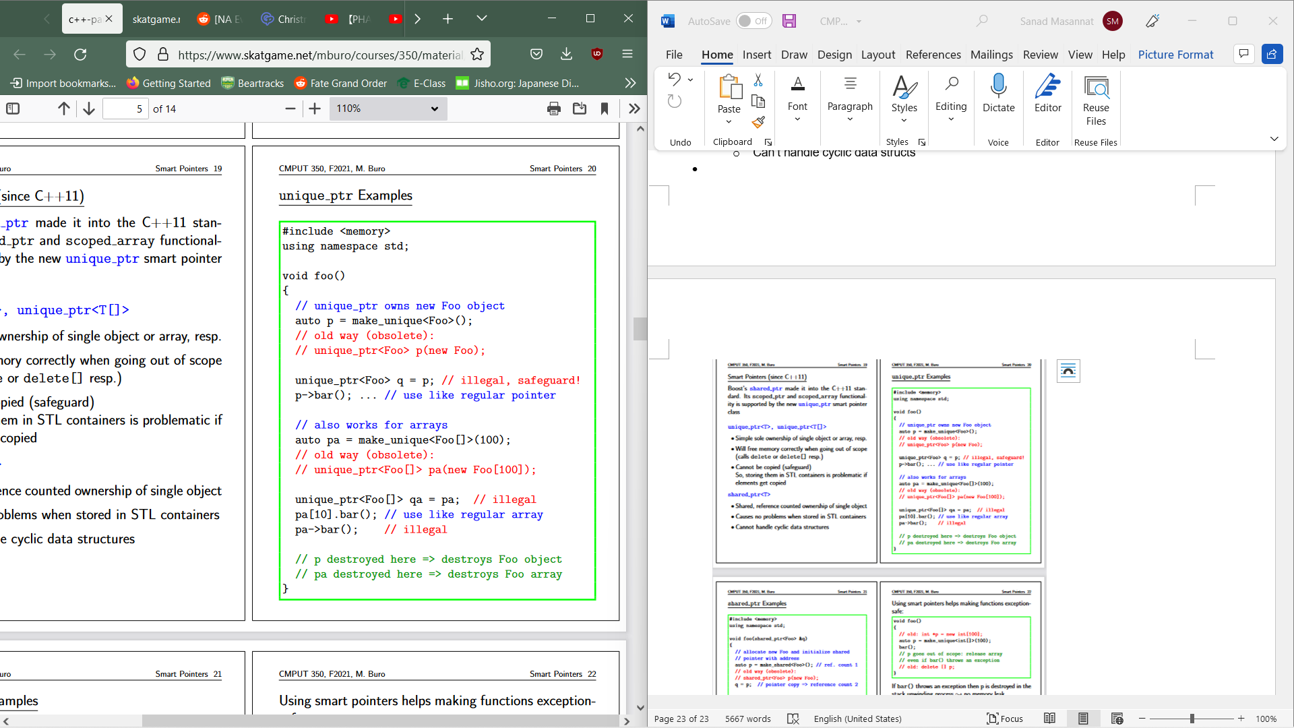

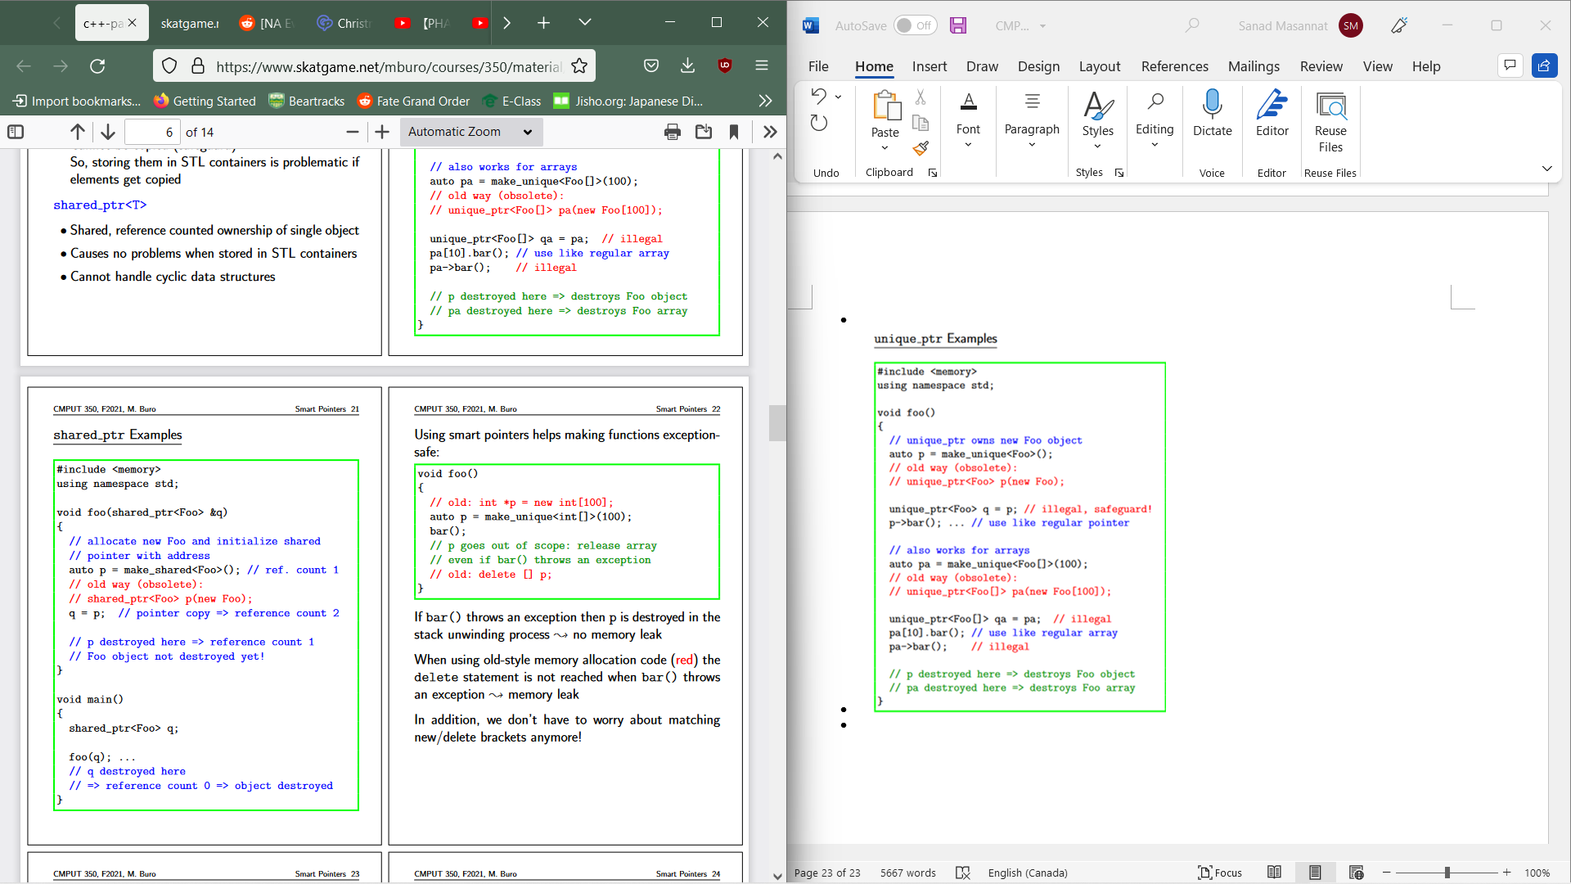

AI Notes

* Most video game Ais are scripted
* No good AI solutions which require few CPU cycles
* We usually let AI cheat
* Most of the time C++ is used:
  + Easier to write bug-free code
  + Maintenance of projects is much easier
  + Large no. of libraries
  + More memory efficient
* Path Planning: Want to move from some object to another avoid obstacle
  + Need to avoid obstacles by some margin(Robotics) or need to be fast/memory efficient(Games)
  + Quickest=Optimal in this case
  + Needs to obey constraints
  + When interacting with terrain features/environment, we need to deal with a loss/gain in time
  + There is usually a trade-off between search complexity and the quality of the path found
  + Most algorithms dealing with this have to deal with a dynamic map. As such, adding/removing objects van be expensive in abstractions or geometry based systems. They must also use simple object avoidance methods that try to follow high-level paths while also resolving conflicts
* Map Representations:
  + Important for path planning
  + Need to ask various questions: Is an optimal path needed? Is world dynamic or static? Do we know the world or is it randomly generated? Constraints? How much memory is available?
* As maps can be hue, we want to avoid picking way points or room abstractions manually, These should be automatically generated from geometry.
* The main approach to path planning in continuous spaces is to discretize continuous height fields so we can make a search graph. Objects move on a 2D surface, so mapping height field to a plane is generally sufficient.
* Grid Based Path Planning:
  + +:
    - Simple
    - Local changes🡪local effects
    - Good representation for tile based stuff
    - Easy path planning
  + -:
    - Imprecise barrier representation
    - Tough for non-tile size objects
    - An increase in precision increases complexity
    - May need to process paths again to allow angular movement
* Geometric Representations:
  + World is initially empty simple shape
  + Polygons are obstacles
  + Aim is to find a path between two points which don’t cross constraints
  + +:
    - Arbitrary polygon obstacles and motion angles
    - Memory efficient
    - Fining paths for circular objects are easy
    - Topological abstractions
  + -:
    - Complex coding
    - Robust
    - Point localization is not constant anymore
* Visibility Graphs
  + Place nodes at corners near obstacles and edges between nodes which are able to connect to each other without curving
  + Find a path from a to b and add these nodes to a graph and connect visible nodes. Then run any path finding alg on graph
  + High memory due to nodes being able to potentially see every other node
  + Corner-corner visibility is expensive
  + Connecting start to end could take linear time
  + Could be optimal but any changes to world is expensive
* Free-Space Decompositions:
  + Decompose empty areas into convex shapes
  + Create way point graph by placing nodes on unconstrained edges and in interior if needed
  + Connect nodes based on direct reachability
  + Find path from A to B by locating faces in which A and B reside then connect A & B to all face nodes. Then we can find a smooth path
* Graph: An (undirected) graph G = (V , E) is a discrete mathematical object comprised of a set of vertices (or nodes) V and a set of edges (or arcs) E. An undirected edge is a set of at most two vertices {u, v}. A directed edge from u to v is an ordered pair (u, v ).
* Graphs describe binary relations between vertices: if edge {u, v } is in  
  E then we say u and v are related. Otherwise, they are unrelated.  
  Graphs can be easily visualized.

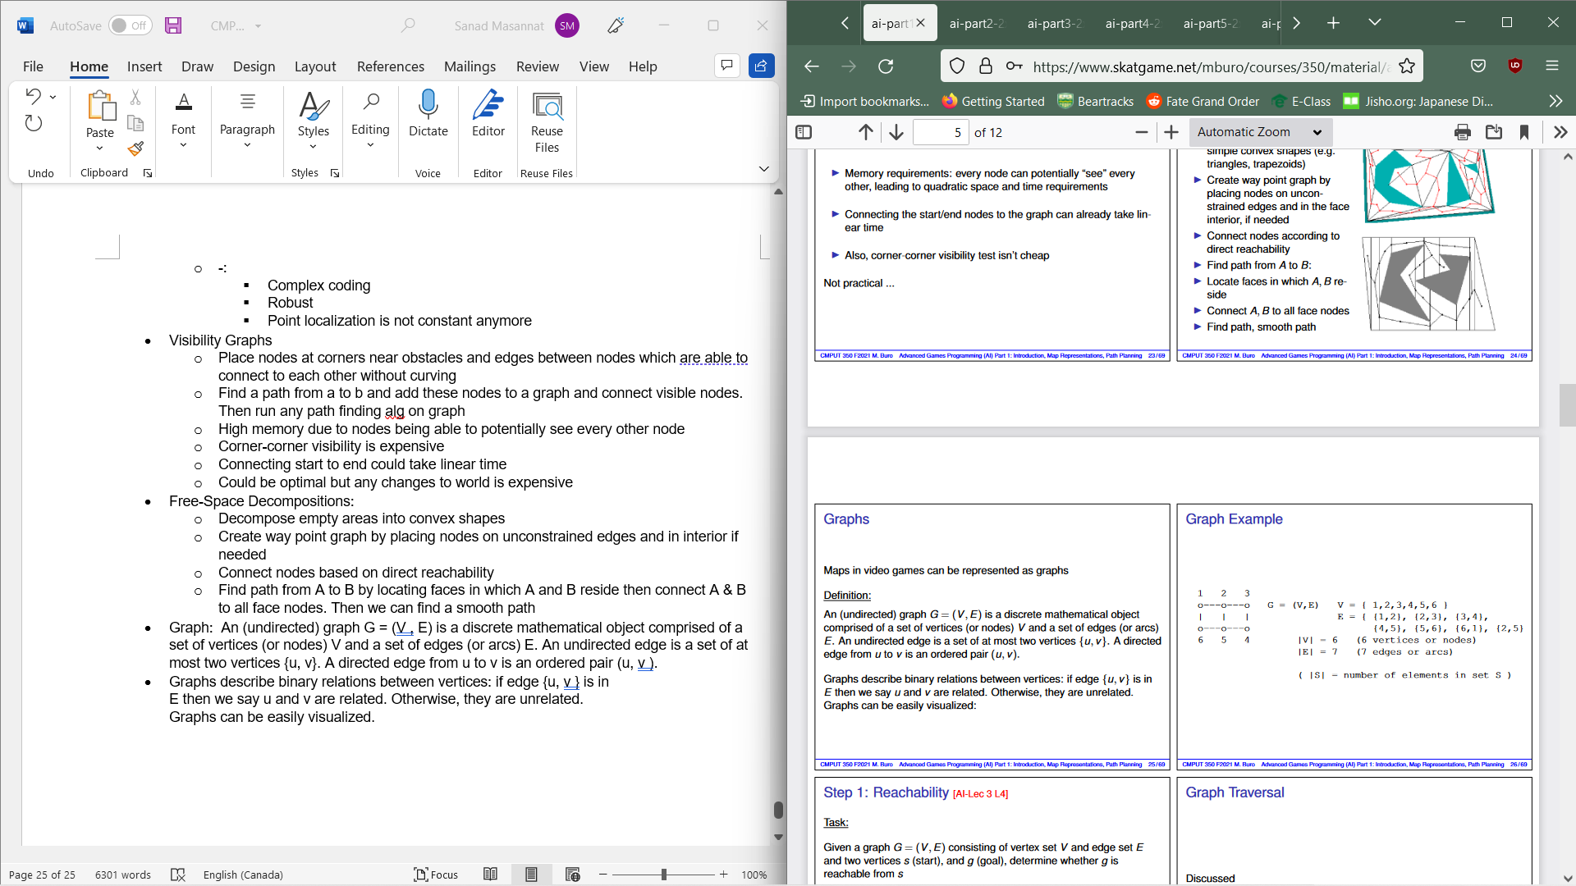

* Reachability: Given a graph G=(V,E) has a vertex set V and edge set E. Determine if the start vertex s is able to reach goal vertex g . This usually means compute all nodes reachable from s.
  + We can use Breath First Search or Depth First Search for the above problem
* Recall: A queue is an ADT that employs First in First Out. Has methods Dequeue, Enqueue and is Empty.
* BFS code & example:
  + // input: graph G, start vertex s, goal vertex g  
    // output: whether we can reach g from s  
    function BFS(G,s,g) {  
    if (s = g) { return true }  
    create queue Q // fringe of nodes yet to be expanded  
    create set R // set of reached nodes  
    enqueue s onto Q  
    add s to R  
    while (Q not empty) { // (*)  
     t ← dequeue element from Q // (1)  
     for each { t, u } in E[G] {  
     if (u = g) { return true }  
     if (u not in R) {  
     add u to R // (2)  
     enqueue u onto Q  
     }  
     }  
     }  
     return false  
    }

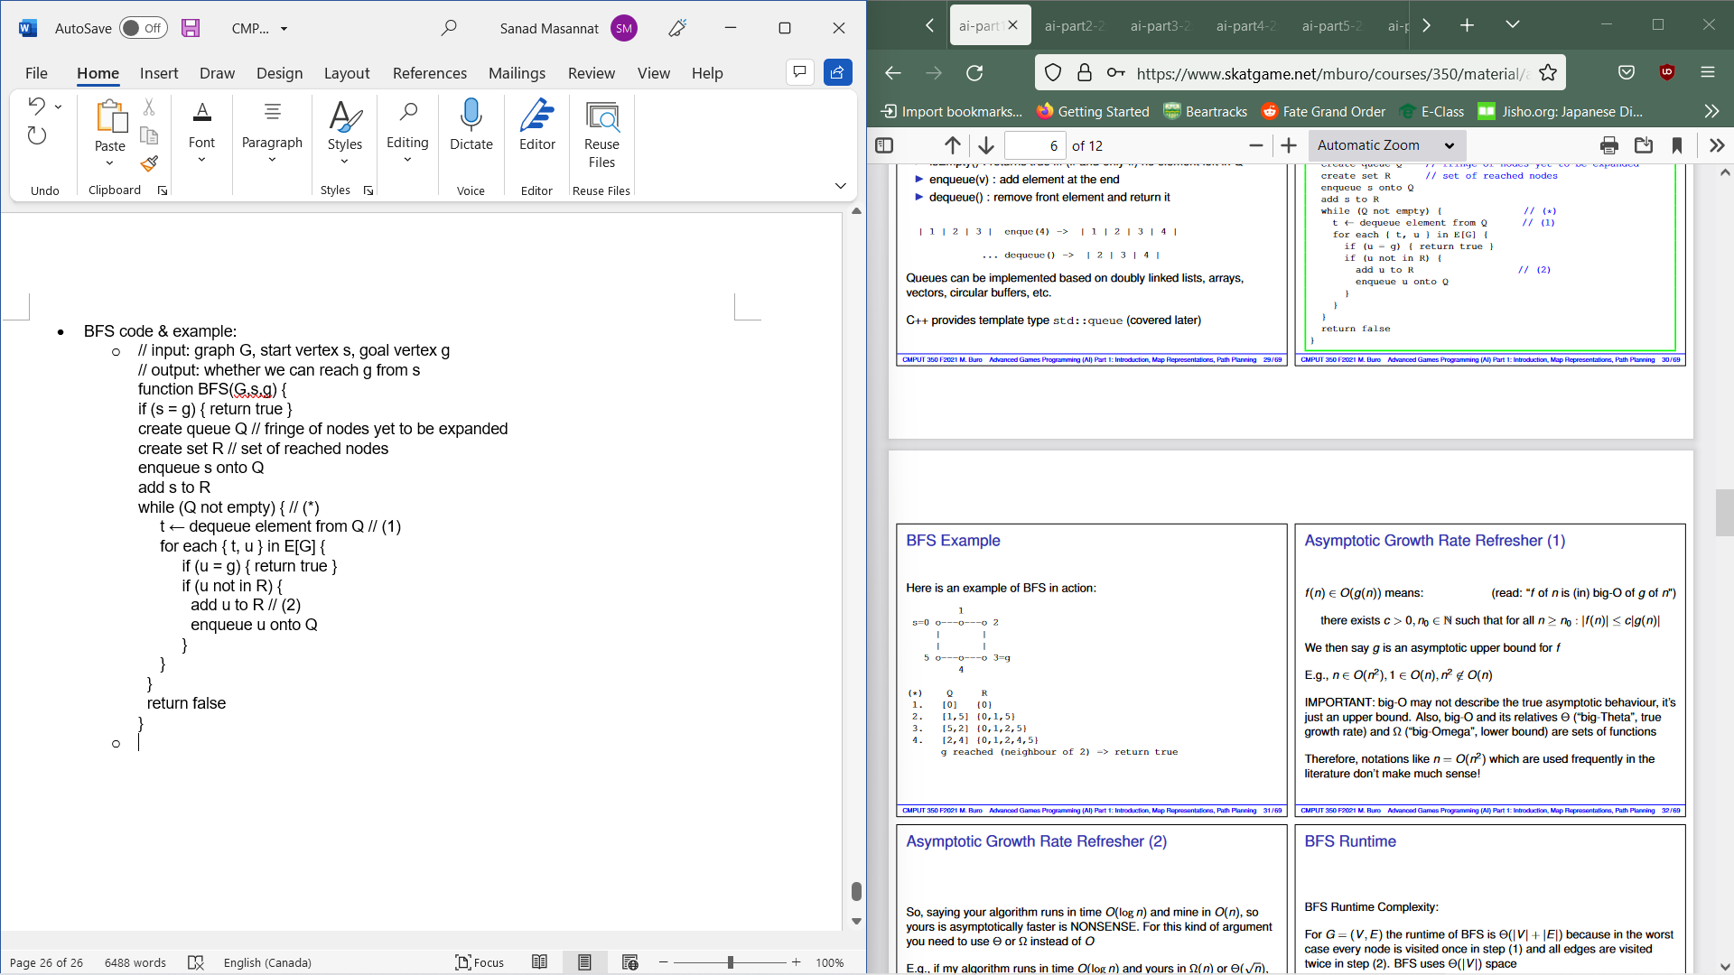

* + Recall: f (n) ∈ O(g(n)) means that there exists c>0, n0 ∈N for all n >=n0 : |f (n)| ≤ c |g(n)|. We then say that g is an asymptotically upper bound for t
  + For BFS, runtime is Θ(|V | + |E|) as in the worst case scenario, every node will be visited once and edges twice. It has a space of is Θ(|V |)
* Given a weighted graph G = (V , E, w) and a start vertex s, determine the shortest distance to all reachable nodes. Weight function w assigns a weight (or distance) ≥ 0 to each edge (and by extension to paths).
  + Dijkstra’s algorithm solves single source shortest path problem in each iteration I, it will generate a reached set alongside an array d which d[v] is minimal distance from s to v and the minimum distance from s to v if v !∈ Si and all but the last node  
    along the paths are in Si
* Using the above array, Dijkstra’s alg maintains the current distance for every node and in each iteration will expand the number of visited nodes Si by closest node u that is reachable in a step. Afterwards, the distances of neighbors of u is updated into Si+1 which could decrease when considering paths through u.
* Suppose there is another path (q) from s to u which is shorter than our supposed optimal path(p) and is also the shortest overall. Then q would leave the vertex set with established minimal distance Si somewhere else . This leads to so w(q)<w(p) 🡪 d[y]+w(rest of q after y)<d[u] 🡪 ( all weights >=0) d[y]]<d[u] which contradicts the algorithms choice of u. Therefore w(q)>=w(p) and P1 is optimal.
* Dijkstra Pseudocode:
  + // input: weighted directed graph G and start vertex s (weights >= 0)  
    // output: minimal distances from s to all vertices (d[]),  
    // parent indexes for constructing shortest path (p[])  
    function Dijkstra(G=(V,E,w), s) {  
     for each vertex v in V { // initializations  
     d[v] ← ∞ // unknown distance from s to v  
     p[v] ← -1 // previous node on optimal path from s  
     }  
    d[s] ← 0 // distance from s to s  
    Q ← V // all nodes are unoptimized  
    while (Q is not empty) { // (*) main loop  
     u ← vertex in Q with smallest distance in d  
     remove u from Q  
     if (d[u] = ∞) { break; } // all remaining vertices inaccessible  
     for each (u,v) in E {  
     alt ← d[u] + w((u,v)) // w maps edge to distance  
     if (alt < d[v]) {  
     d[v] ← alt // found shorter path to v  
     p[v] ← u // memorize parent  
     } }  
     }  
     return (d, p)  
    }
  + Example:
    - 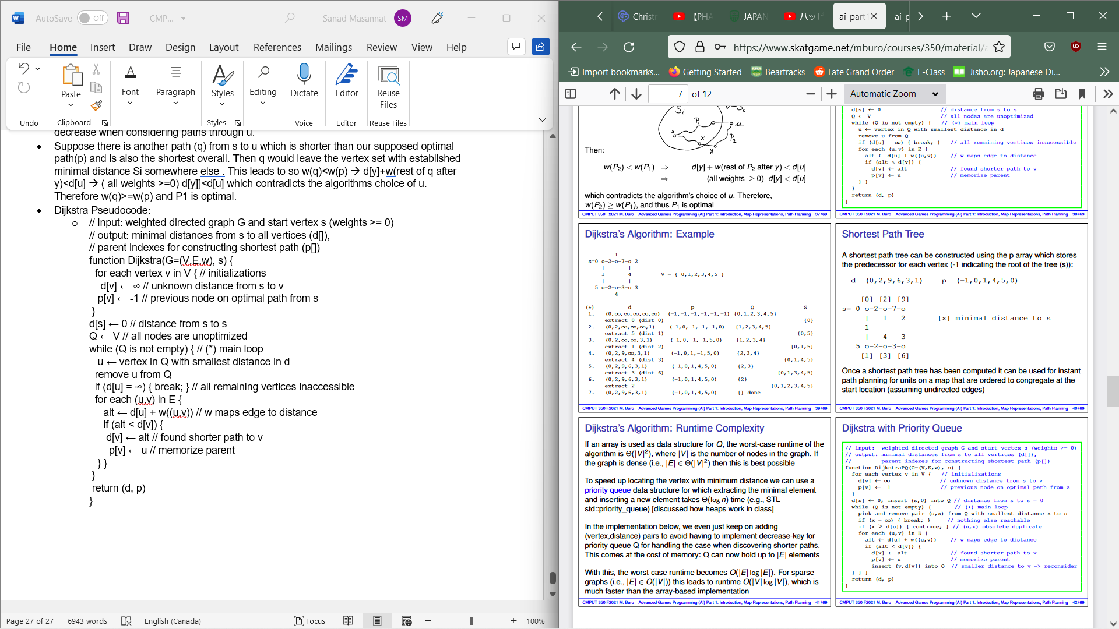
  + Using the P array(which stores the predecessor of each vertex, a shortest path tree can be constructed). And once computed, it can be used for instant path planning for units on a map which are ordered to congregate at start location
  + If an array is used as data structure for Q, the worst-case runtime of thealgorithm is Θ(|V |2), where |V | is the number of nodes in the graph. If the graph is dense (i.e., |E| ∈ Θ(|V |2) then this is best possible.
  + To speed up locating the vertex with minimum distance we can use a priority queue data structure for which extracting the minimal element and inserting a new element takes Θ(log n) time (e.g., STL  
    std::priority_queue)
  + In the implementation below, we even just keep on adding (vertex,distance) pairs to avoid having to implement decrease-key for  
    priority queue Q for handling the case when discovering shorter paths. This comes at the cost of memory: Q can now hold up to |E| elements
  + With this, the worst-case runtime becomes O(|E| log |E|). For sparse graphs (i.e., |E| ∈ O(|V |)) this leads to runtime O(|V | log |V |), which is much faster than the array-based implementation
  + Code: // input: weighted directed graph G and start vertex s (weights >= 0)  
    // output: minimal distances from s to all vertices (d[]),  
    // parent indexes for constructing shortest path (p[])  
    function DijkstraPQ(G=(V,E,w), s) {  
     for each vertex v in V { // initializations  
     d[v] ← ∞ // unknown distance from s to v  
     p[v] ← -1 // previous node on optimal path from s  
     }  
     d[s] ← 0; insert (s,0) into Q // distance from s to s = 0  
    while (Q is not empty) { // (*) main loop  
     pick and remove pair (u,x) from Q with smallest distance x to s  
     if (x = ∞) { break; } // nothing else reachable  
     if (x ≥ d[u]) { continue; } // (u,x) obsolete duplicate  
     for each (u,v) in E {  
     alt ← d[u] + w((u,v)) // w maps edge to distance  
     if (alt < d[v]) {  
     d[v] ← alt // found shorter path to v  
     p[v] ← u // memorize parent  
     insert (v,d[v]) into Q // smaller distance to v => reconsider  
    } } }  
    return (d, p)  
    }
  + Dijkstra’s original algorithm initializes the queue with all nodes in the beginning. This wouldn’t work if the search space is large (or even infinite). There is another search algorithm called “Uniform Cost Search” (UCS) which is essential mimicking Dijkstra’s computation using a smaller queue, which is initialized with the starting node (like our priority queue based algorithm).
  + Dijkstra’s algorithm adds new nodes by referring to previously computed shortest distances
* Heuristic Search/Single Agent Search is similar to Dijkstra’s but instead of just looking back, it also looks forward
* For a node n (representing partial solution (search state as opposed to a problem state), we define:
  + F(n)=g(n)+h(n) where g() is cost of path so far and h() is heuristic estimate of the cost of reaching the goal from node n
* A* expands node on queue with lowest f value
* We end until we expand the goal state
* Structs in A*:
* State:  
  Object that describes the current problem state. E.g., location of agent on a map for path planning, or orientation of cubies for Rubik’s Cube  
  Node: Object that encodes a partial problem solution Contains: state, f, g, parent pointer (and optionally an action)  
  OPEN:  
  Container of nodes at the search fringe that will be considered next  
  CLOSED:  
  Container of nodes that have been fully expanded  
  OPEN + CLOSED:  
  Nodes we have seen so far
* Main Loop: remove lowest f node n from open and if goal then stop. Regardless of goal or not, move n to closed. We then expand by considering children. Here we check is state is in open or closed and if a state has been seen with a similar or smaller g value, we reject otherwise we remove a child state from open and closed and add corresponding node to open for consideration .
* 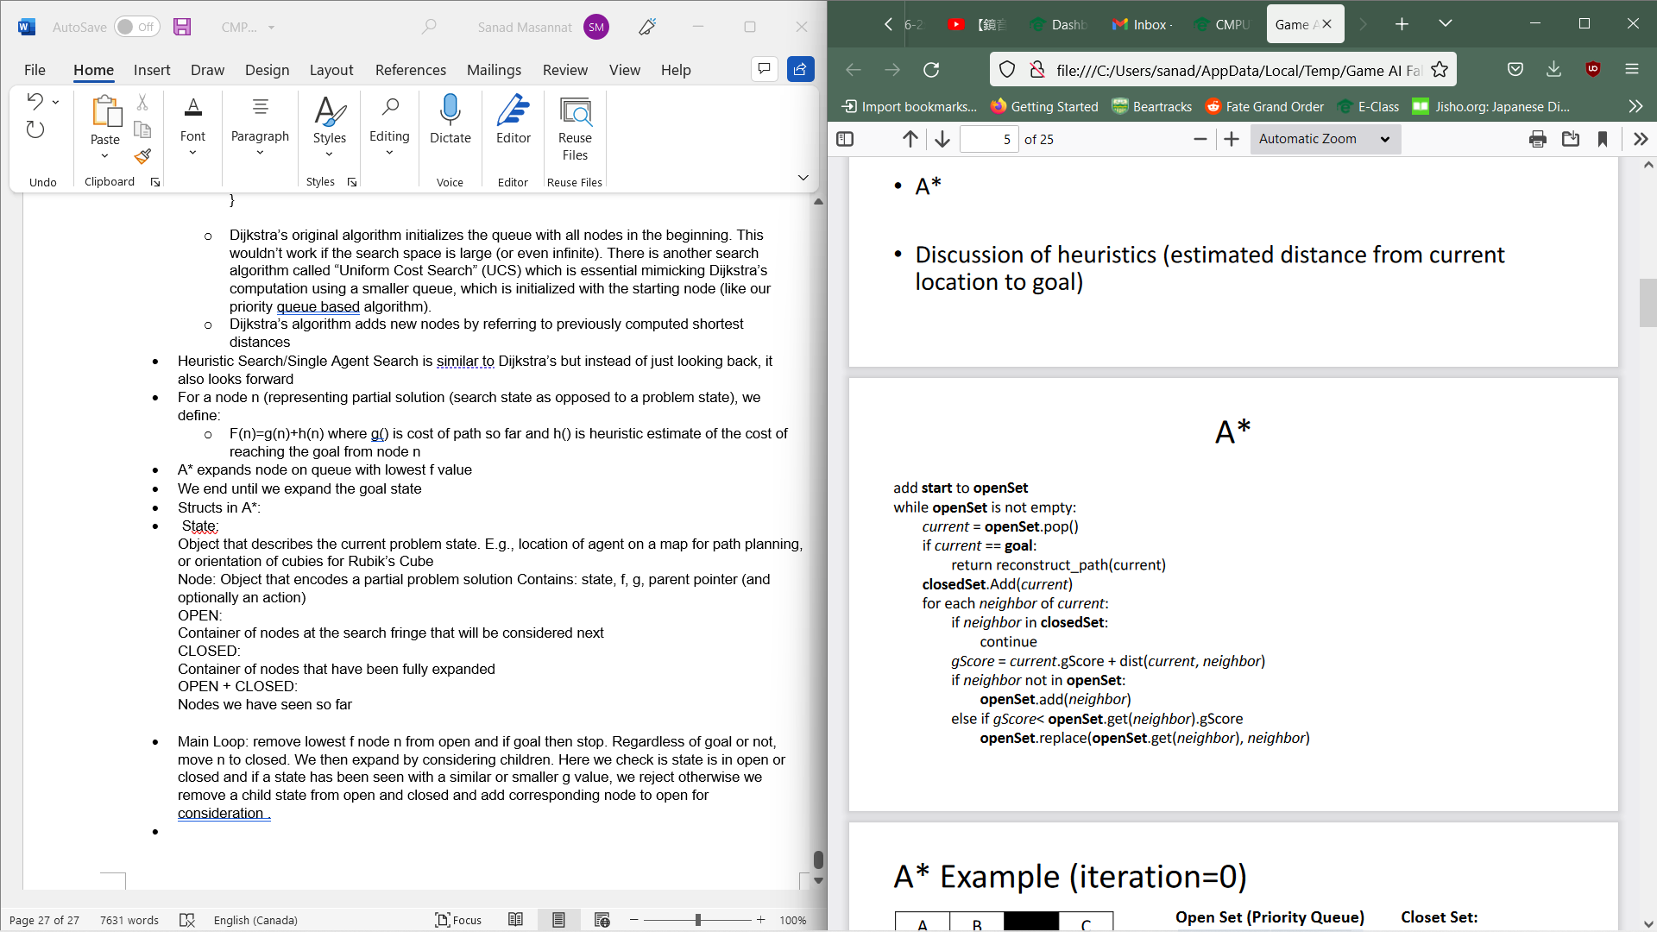
* Admissible heuristic is one if and only if h(n) ≥ 0 and h(n) ≤ h∗(n) for all n where h*(n) is the true minimal cost to goal from node n
* Consistent heuristic is one if h h(G)=0 for all goal states G and h(n)<=cost(n,s)+h(s) for all nodes n and their successors s
* Proof A* is correct:
  + Theorem: Applied to graphs with bounded node neighborhoods and edge costs≥ € > 0, A∗ using an admissible heuristic h returns “success” and an cost-minimal path, if one exists, or “failure” otherwise in case the graph is finite
  + We assume goal G is reachable from S (otherwise A∗ reports “failure” which can be proved by showing that in this case A∗ visits all nodes reachable from S – homework (induction on minimal number of steps needed to reach a node))  
    Define C∗ = minimal cost from S to G
  + 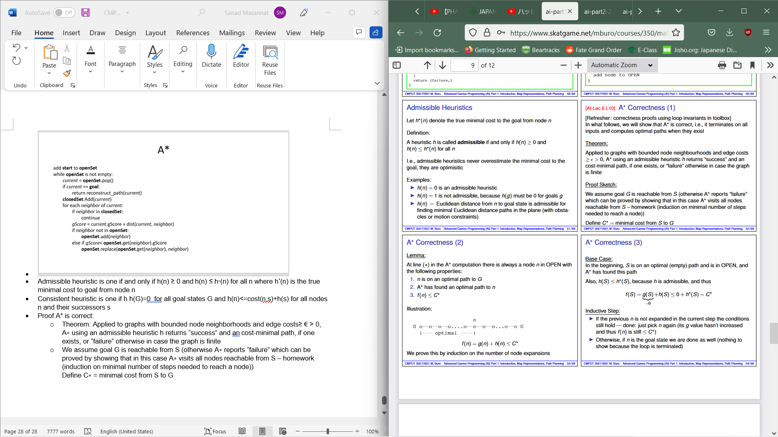
  + 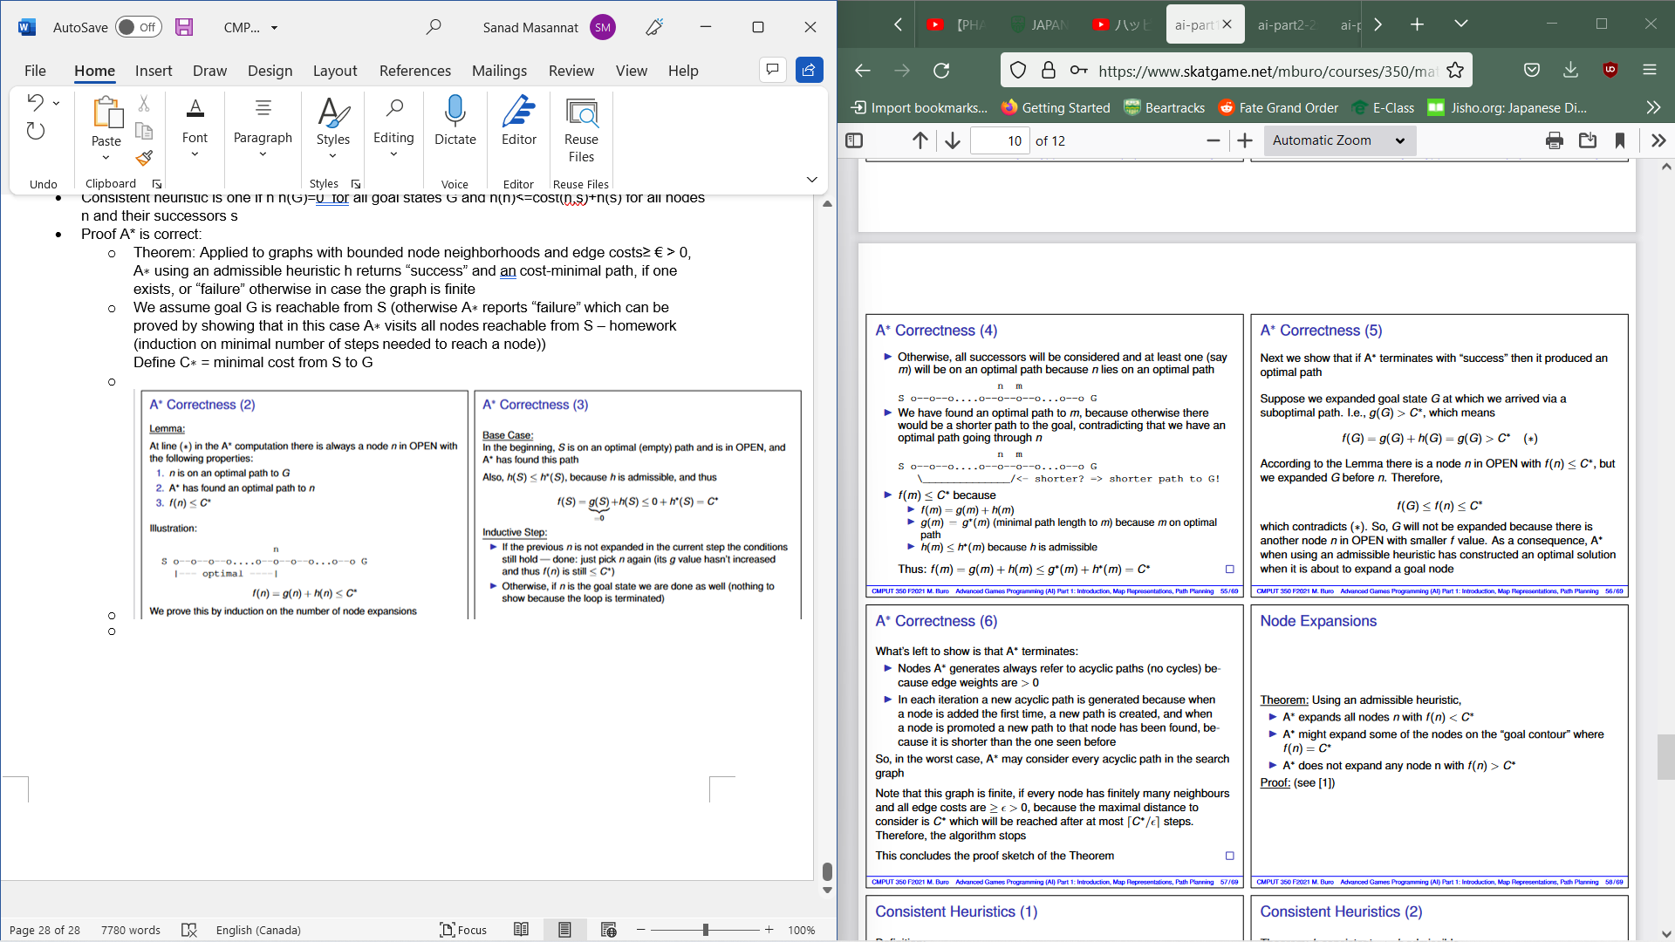
  + For the closed set: wee could use a map struct which maps states to node pointers and for open, we could use a priority queue of node pointers based on f values alongside state-to-node pointer map
  + If a consistent heuristic is used, a* can be simplified as no better path ot nodes will be found in subsequent searches
  + Optimizing A*:
    - Breaking f value ties in favour of larger g values: using less heuristic approximation is empirically better
    - As we have seen, priority queues allow us to find the node with minimal f value in time O(log n), where n is the number of queue elements (e.g., C++ STL priority_queue<T,Compare>)
    - We can use hash tables for OPEN/CLOSED membership to avoid  
      scanning lists, or if the entire graph fits in memory, we can associate two flags with each search state: “in OPEN?” and “in CLOSED?”. With this, membership test is really fast (constant time)
    - If A* run multiple times on same graph, we can decrease initialization cost of clearing open and closed before each A* run using the generation counter trick
      * each flag becomes an integer, initialized with 0 (meaning “false”)  
        set the generation counter (gc) to 1  
        setting flag = gc indicates true, flag != gc means false  
        before the next A∗ run, increment gc  
        (this implicitly sets all flags to false in constant time!)  
        set all flags to 0 if gc exceeds big value and reset gc to 1
  + Complexity:
    - Successor nodes generated on fly
    - Exponential time complexity in worst case
    - Good heuristic helps
    - Runtime is O(bm*log(bm)) if heuristic is perfect
    - Exponential space complexity in worst case
  + If all nodes fit in memory, time complexity is often O(n log n)
* Advanced Path planning
  + Hierarchical Pathfinding A* (HPA*)
    - Steps: Pre-process
      * Superimpose sectors on top of grid
      * Build a graph with one or more nods per sector entrance
      * Computer intra-sector distances
    - Find path in graph then smooth it
    - Code:
      * // input: start location s, goal location g  
        // output: approx. of shortest path from s to g  
        // or failure  
        // (assumes pre-processed map)  
        function HPA*-FindPath(s,g):  
        locate sectors containing s and g  
        add intra-sector edges from s,g to entrances  
        compute distances from s and g to respective  
        entrances  
        find abstract path from s to g by stitching  
        intra-sectors paths together  
        if none exists return failure  
        smooth path  
        return path
    - Has fast performance without smoothing but is much slower with it
    - Uses Dijkstra’s alg for intra-sector distances
    - Has on demand intra-sector computations
    - Faster window based smoothing
    - +:
      * Suitable for dynamic worlds: local terrain changes only trigger distance computation within a small number of sectors  
        Simple implementation  
        Can build multiple levels of abstraction
    - -:
      * Connecting s and g to the abstract graph can be time consuming  
        Without time consuming smoothing path quality isn’t great (often 0%+ longer than optimal)
  + Path Refinement A* (PRA*)
    - Uses clique abstraction on octile-base grids.
    - Clique : Maximally connected subgraph
    - When abstracting a map, look for cliques and replace them b a single letter. E.g. :
    - 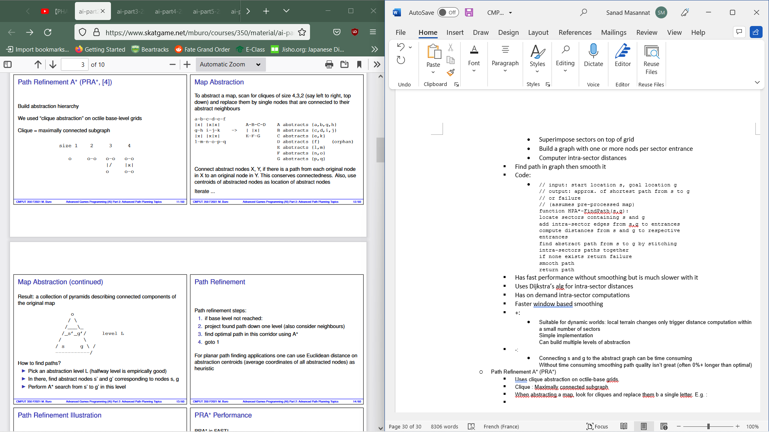
    - \
    - 
    - For path refinement :
      * If base level isn’t reached, project found path down a level then find optimal path via A* an go back to first step
    - PRA Faster than A* with high quality paths
    - After finding path at a level l, project it k levels down
    - Shorter corridor
    - We know global direction
  + Issues with path planning:
    - Crude approximation, objects occupy a whole tile mentality, octile topology
  + We can use free space decompositions to address issues (quad trees, triangulations and trapezoidal decomposition)
  + Basic idea is to decompose area around obstacles into convex shapes then for apth planning, first locate that start s and goal g then hop from area to area and finally smooth it
  + Triangulation:
    - Start with an area and collection of points
    - Add edges between points with crossing over other edges
    - Continue until no possible edges left
    - Triangle base decomposition is made
    - We wish to avoid sliver like convex areas to prevent decrease in quality
    - Delaunay Triangulations are triangulations which maximize sorted interior angle vector(min angle is max) usually done by edge flipping
    - A triangulation maximizes the minimal angle if for each quadrangle the  
      circumcircle of each triangle does not contain the fourth point
    - Computing Steps:
      * 1.Initialize triangulation T with a “big enough” helper bounding triangle that contains all points of P  
        2. Randomly choose a point pr from P  
        3. Find the triangle ∆ that pr lies in  
        4. Subdivide ∆ into smaller triangles that have pr as a vertex  
        5. Flip edges until all edges are legal  
        6. Repeat steps 2-5 until all points have been added to T
      * Θ(n log n)
    - Point localization:
      * Triangles are given as a vector and store co-ordinates and indexes of neighbouring triangles
      * Straight Walk:
        + Start with random triangle then walk towards goal A by crossing edges that intersect the line between A and the opposite initial triangle point
      * Jump and Walk:
        + Sample k triangles and pick the closest to point A as your starting point
      * Sector Based Jump and Walk:
        + Uses sectors and jump and walk
        + Steps:

Preprocessing

Maintain starting triangle for each sector

Locate (x,y) compute sector and start walking at sector start triangle

If none exist, use jump and walk method and store triangle found in sector

* + - * Constrained Triangulations:
        + Triangulations where certain edges are required to be inside triangulations then others are added. These maximize the min angle while keeping angles
      * Robustness of geometric computations:
        + Using fixed float arithmetic can cause geometric algs to crash, to hang to produce incorrect output
      * For triangular passed path planning, use constrained triangulations with barriers represented as constraints, the find the triangle at start point is in and search adjacent triangles across unconstrained edges and finally find a channel of triangles inside which we can easily determine shortest path.
      * +:
        + Remedies grid-based  
          methods’ deficiency with  
          off-axis barriers  
          Representing detailed areas better doesn’t complicate “open” areas  
          Triangulations have much  
          fewer cells and are more  
          accurate than grids  
          Can deal with non-point objects quite easily
      * -:
        + Curved obstacles must be  
          approximated by straight segments  
          We do not know what path we will take through the triangles until after we have found  
          the goal  
          This can lead to either suboptimal paths or multiple paths  
          to triangles
      * To find path through channel of triangles: use funnel alg. This finds the shortest path in polygon in linear time.
      * Maintains a funnel which contains the shortest path to channel endpoints so far and funnel is updated for each new vertex in channel by finding the wedge in which the new endpoints lie.
      * We can make use of a modified funnel alg to deal with circular objects with a non-zero radius. In conceptually attached circles of equal radii around vertex of channel while considering segments tangent to these circles and arcs along them.
      * Naive search: Assume straight segment paths between edge mid-pont. Run A* from start triangle looking for goal triangle where g is the sum of straight segment lengths onn path while h is the Euclidean distance between current point and goal.
        + +:

Paths are found easily as it considers each triangle once and good distance measures

* + - * + -:

Results in sub-optimal paths occasionally.

* + - * + To find optimal path:

Underestimate the distance travelled so far (e.g., take minimum  
distance of reaching any point in current triangle)  
Allow multiple paths to any triangle  
When a channel is found to the goal, calculate the length of the  
shortest path in this channel using the (modified) funnel algorithm  
If it is the shortest path found so far, keep it;  
otherwise, reject it (anytime algorithm)  
When the lower bound on the distance travelled so far for the paths  
yet to be searched exceeds the length of the shortest path, the algorithm ends and we have found an optimal path

* + Triangulation A* (TA*):
    - Search running on the base triangulation  
      Uses a triangle for a search state and the adjacent triangles across unconstrained edges as neighbours  
      Using anytime algorithm and considering multiple paths to a triangle as described earlier  
      For a heuristic (h-value), take the Euclidean distance between the goal and closest point on the triangle’s entry edge  
      Calculate an underestimate for the distance-travelled-so-far (g-  
      value)   
      Only consider triangles once until the first path is found  
      Continue searching until time runs out or lower bound meets or  
      exceeds current shortest distance
  + Triangle reduction:
    - We want to reduce triangulation without losing topological struct
    - Determine triangles as being decision points
    - Map triangle to a degree-n node when it has exactly n triangles adjacent across unconstrained edges and after mapping, collapse degree 2 corridors
    - 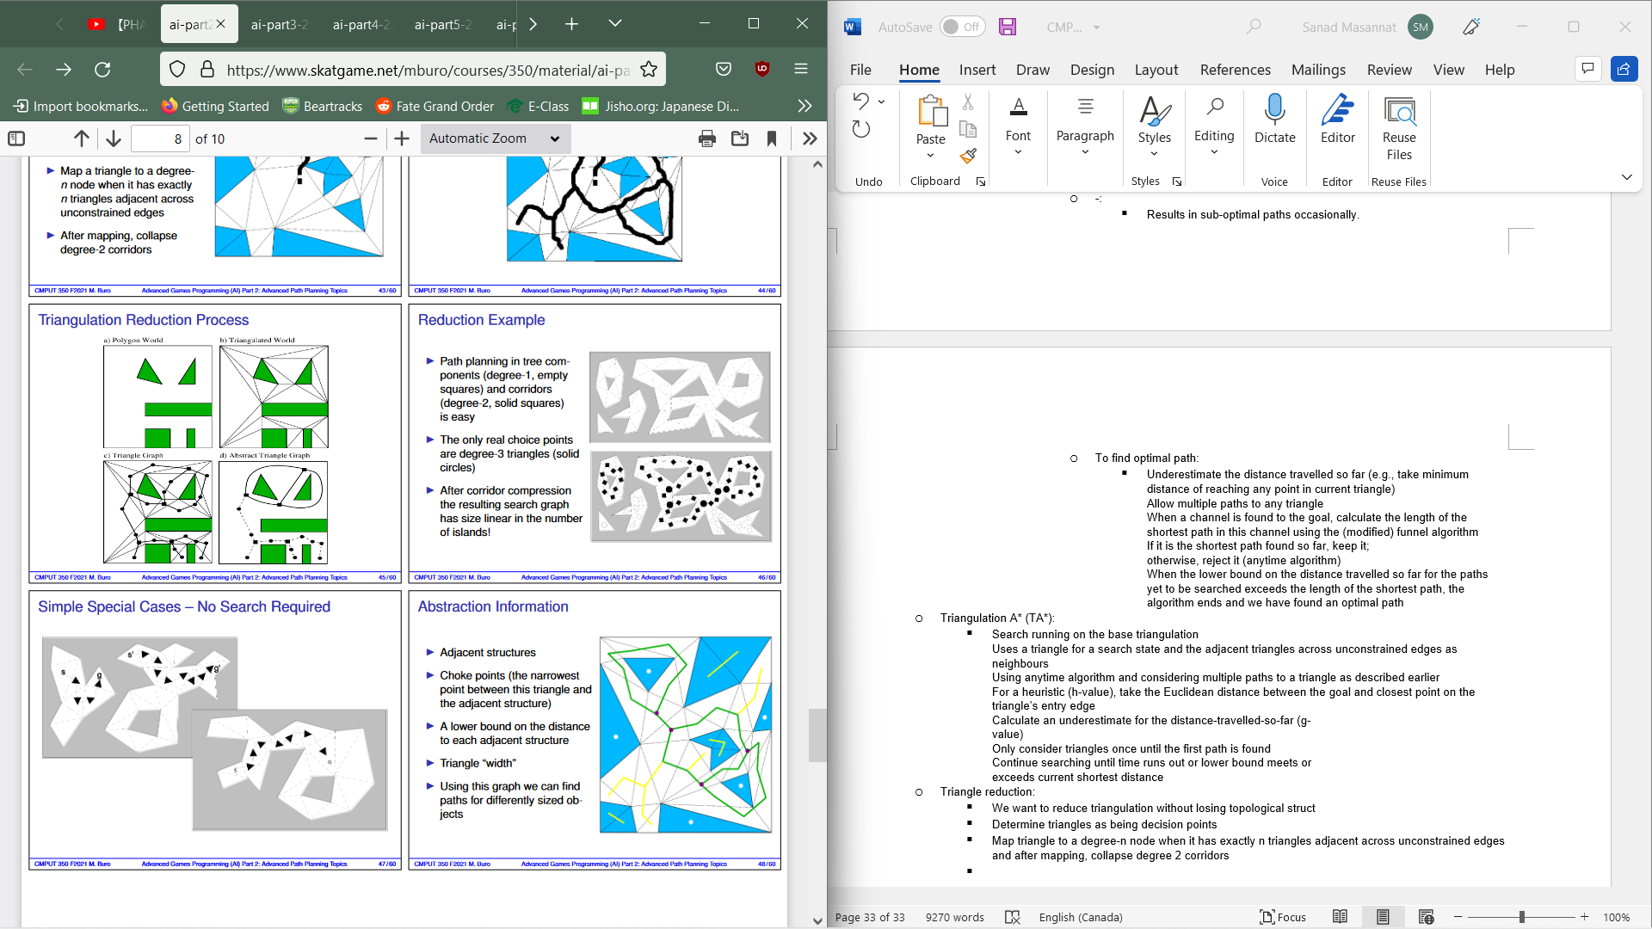
  + Triangle Reduction A*(TRA*)
    - TA* running on abstraction we just described
    - First checks for a number of special cases in which no searching needs to be done
    - Move from start and goal to adjacent degree 3 nodes and use those as search states and generate children as degree 3 nodes adjacent across corridors
    - Like TA*, use anytime alg to allow multiple paths to a node and use same g and h values
* Multi-agent path planning
  + We want to deal with several units, leads to a problem/challenges such as choke points, formation and potential opponent denying access.
  + A Naive approach to this is for every unit to path individually and for squads, one unit could path find and the rest follow it.
  + Myopic self centered views leads to serious problems in confined area and in the worst case, multiagent pathfinding problems turns into sliding tile puzzles
  + Shortest solution is NP hard in general
  + A simple yet prone to failure is to assume our world is static plans paths with A* and will replan when something changes
* We wish to avoid space-time collision(two objects being in the same place at the same time) which can be done using A*
* ORTS Kinematics System
  + Open Real Time Strategy
  + Game servers sees world as lines and circles
  + Segments are obstacles for moving options
  + When the circles collide with segments, they stop
* 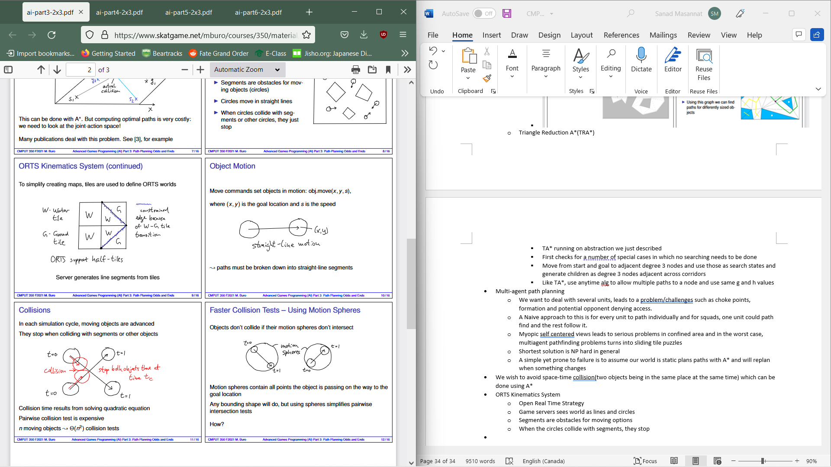
* 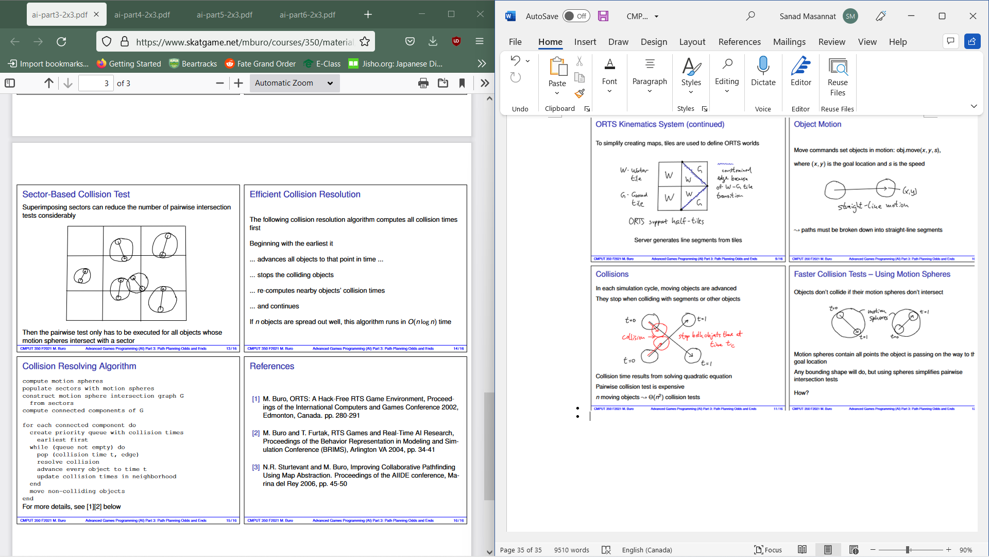
* Collision Resolving Alg:
  + compute motion spheres  
    populate sectors with motion spheres  
    construct motion sphere intersection graph G  
    from sectors  
    compute connected components of G  
    for each connected component do  
    create priority queue with collision times  
    earliest first  
    while (queue not empty) do  
    pop (collision time t, edge)  
    resolve collision  
    advance every object to time t  
    update collision times in neighborhood  
    end  
    move non-colliding objects  
    end
* Game defined by following components:
  + P:The set of players which act
  + S: The set of game states
  + S0 ∈ S : The start state
  + T : S 🡪 2S:Move transition function which defines for each state what states are directly reachable. During game play, in state s, player M(s) chooses the successors from T(s)
  + E ⊆ S: Set of end states. When reaching a state s ∈ E, the game ends. T(s) = ∅
  + R: E 🡪 R|P| : The reward/payoff function which assigns a reward value to each player in terminal state
  + I: info set structure which defines what players know about the state of the game
* Hex example:
  + 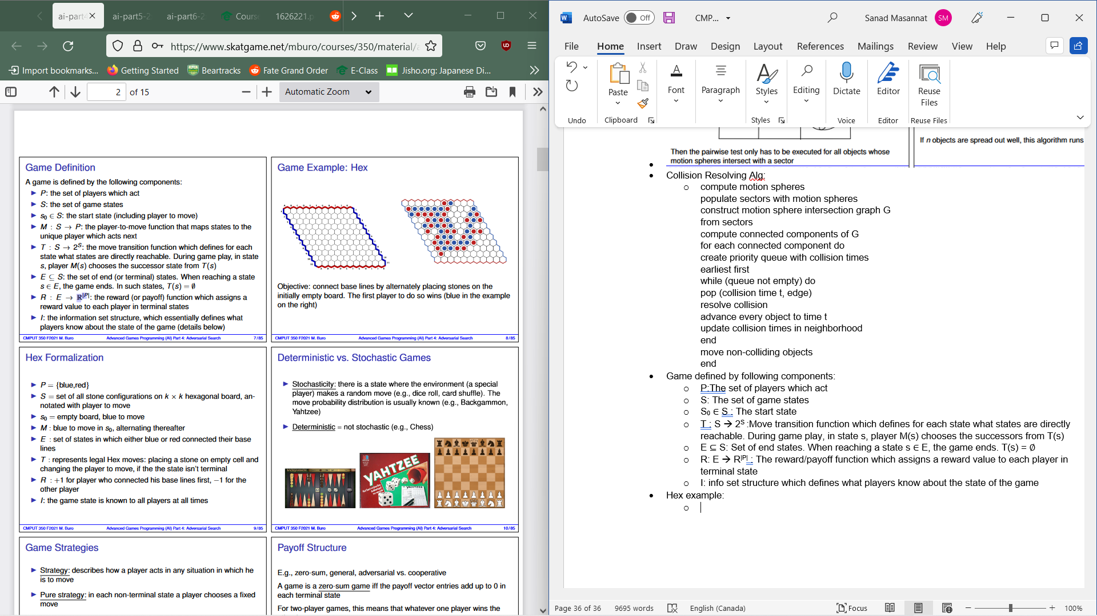
  + Stochasticity: State where environment makes a random move. The move probability distribution is known
  + Deterministic: Not stochastic
  + Strategy: How a player acts in any situation which he is to move
  + Pure Strategy: In each non-terminal state a player chooses fixed move
  + Mixed Strategy: A player chooses move according to probability distribution
  + Nash-equilibrium strategy profile: Players selecting their strategies so that no one has an incentive to change strategy unilaterally
* A game is a zero-sum game if payoff vector entries add up to 0 in each terminal state(2 player games, whatever one players wins the other loses)
* Info Set: Set of possible game states which the player to move distinguish, determined by the players’ private knowledge about game state and observable move history.
* Perfect Info: All info sets have size 1 whereas Imperfect info: there exists an info set with size > 1.
* We can model RPS by hiding the 1st move which is accomplished with info sets which consist of game states the player cannot distinguish.
* 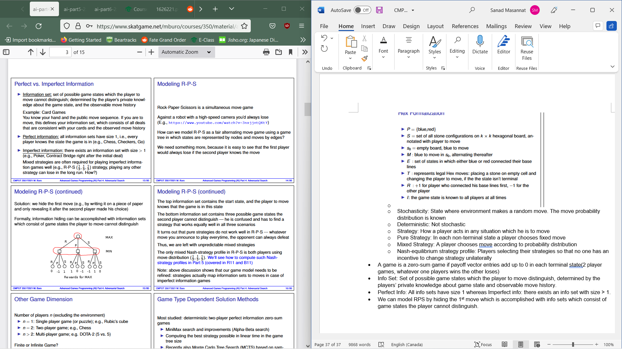
  + Top info set contains start state and the player to move knowns game is in this state
  + Bottom info set contains 3 possible game states the 2nd player cannot distinguish, needs to finds a strategy that works in all three scenarios
  + We are left with unpredictable mixed strategies(using move distribution 1/3, 1/3, 1/3)
* Single player : n=1, two player game n=2, multiplayer n>2
* Infinite games, winning depends on property of infinite move sequence and can only be used for proving properties of concurrent software systems such as liveness
* For deterministic two player imperfect zero sum games:
  + MiniMax search and improvements used
  + Computing best strategy possible in linear time in game tree size
  + MCTS is also used
  + Hard to compute good strategies based on solving linear functions
  + Computation still polynomial in the game tree size
* For stochasticity + perfect info:
  + ExpectiMax
  + Minimax
* 
* Zero-sum means: The amount one player gains at the end of a game the other one loses
  + Max tries to maximize his score while MIN tries to minimize MAX’s score
  + Perfect Info: At any time each player knows the state of the game.
* Game Trees:
  + The search space is usually represented by a game tree
  + 
  + Depth of a node: number of state transitions from start to given position
  + Height of a node: Maximum number of a moves to reach of movesto reach a leaf from current node
  + Branch Factor: Average or max number of successor nodes
* MinMax Alg:
  + Determines the value of a state in view of player MAX assuming optimal play by recursively generating all move sequences, evaluating reached terminal states and backing up values using min max rule
  + 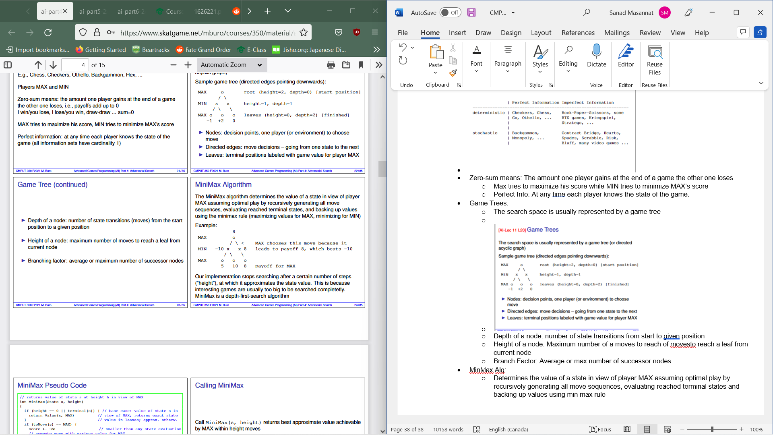
  + Pseudocode:
    - / returns value of state s at height h in view of MAX  
      int MiniMax(State s, height)  
      {  
      if (height == 0 || terminal(s)) { // base case: value of state s in  
      return Value(s, MAX) // view of MAX; returns exact state  
      } // value in leaves; approx. otherw.  
      if (toMove(s) == MAX) {  
      score ← -∞ // smaller than any state evaluation  
      // compute move with maximum value for MAX  
      for (i ← 0; i < numChildren(s); ++i) {  
      value ← MiniMax(child(s, i), height-1)  
      if (value > score) { score ← value } // found better move  
      }  
      } else {  
      score ← ∞ // bigger than any state evaluation  
      // compute move with minimum value for MAX  
      for (i ← 0; i < numChildren(s); ++i) {  
      value ← MiniMax(child(s, i), height-1)  
      if (value < score) { score ← value } // found better move  
      }  
      }  
      return score  
      }
  + Call it via minimax(s,height) and will return best approximate value achievable by MAX within height moves and if the height = infinity, it will return exact value of s
* NegaMax Alg:
  + Always evaluates states in view of player to move
  + Pseudocode:
    - / return value of state s in view of player to move  
      int NegaMax(State s, height)  
      {  
      if (height == 0 || terminal(s)) { // base cases  
      return Value(s, toMove(s)) // value in view of player to move  
      } // approximation if not leaf  
      score ← -∞  
      for (i ← 0; i < numChildren(s); ++i) {  
      // this assumes players alternate moves  
      // |  
      value ← - NegaMax(child(s, i), height-1)  
      if (value > score) {  
      score ← value  
      }  
      }  
      return score  
      }
  + Call: result 🡨 NegaMax(s,height)
  + 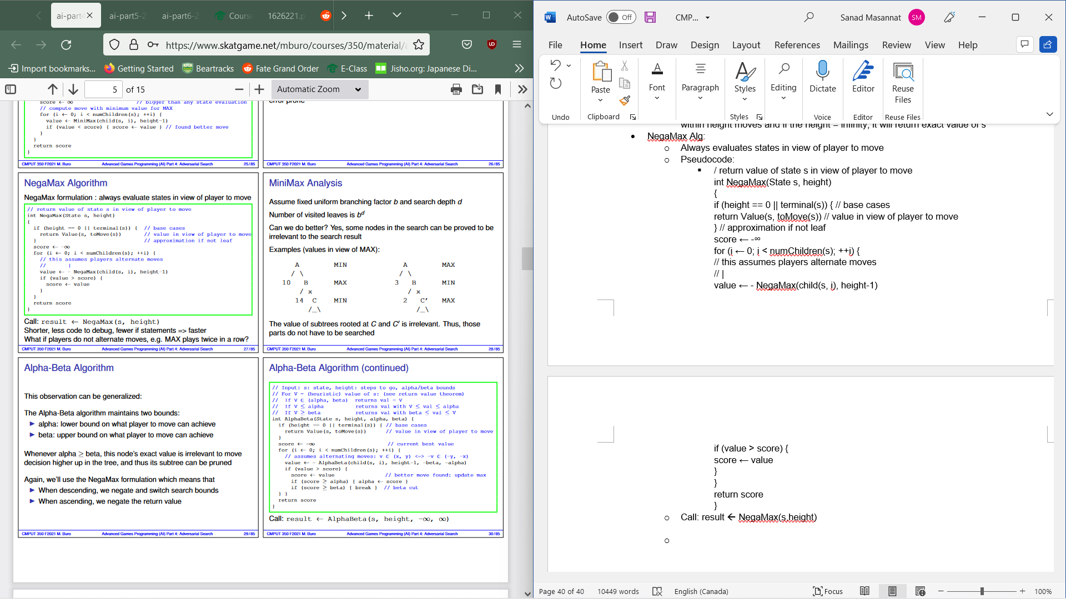
* Alpha-Beta Alg:
  + Maintains two bounds:
    - Alpha: Lower bound on what player to move can achieve
    - Beta: Upper bound on what player to move can achieve
  + Whenever alpha>= beta, this node’s exact value is irrelevant to move decision higher up in the tree and thus its subtree can be pruned
  + When descending, negate and switch search bounds and while ascending we negate return value.
  + Code:
    - / Input: s: state, height: steps to go, alpha/beta bounds  
      // For V = (heuristic) value of s: (see return value theorem)  
      // If V ∈ (alpha, beta) returns val = V  
      // If V ≤ alpha returns val with V ≤ val ≤ alpha  
      // If V ≥ beta returns val with beta ≤ val ≤ V  
      int AlphaBeta(State s, height, alpha, beta) {  
      if (height == 0 || terminal(s)) { // base cases  
      return Value(s, toMove(s)) // value in view of player to move  
      }  
      score ← -∞ // current best value  
      for (i ← 0; i < numChildren(s); ++i) {  
      // assumes alternating moves: v ∈ (x, y) <=> -v ∈ (-y, -x)  
      value ← - AlphaBeta(child(s, i), height-1, -beta, -alpha)  
      if (value > score) {  
      score ← value // better move found: update max  
      if (score ≥ alpha) { alpha ← score }  
      if (score ≥ beta) { break } // beta cut  
      } }  
      return score  
      }
  + 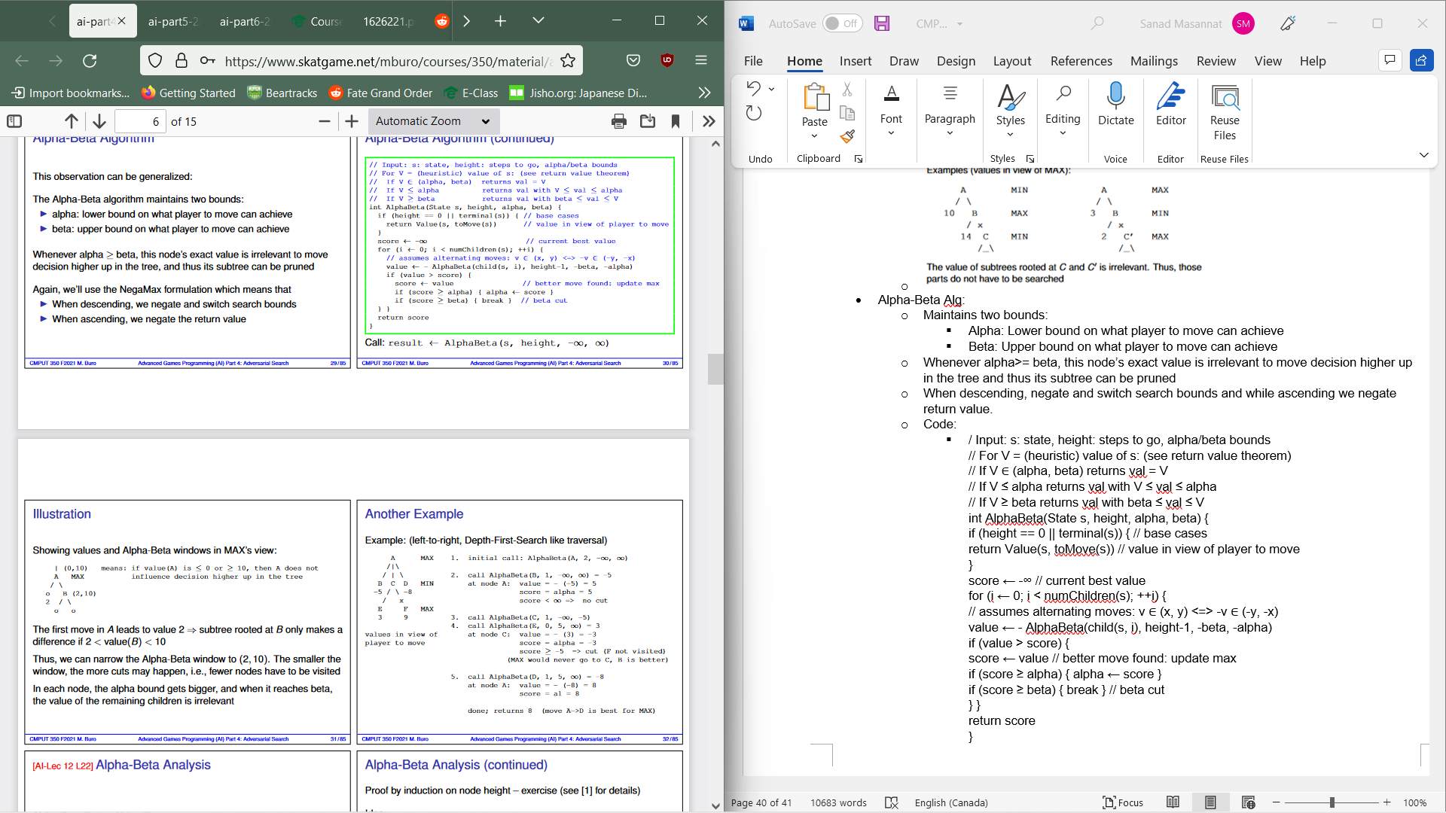
* Alpha Beta analysis
  + Let V(s) be true NegaMax value of state s and h the height of s and let L=alphabeta(s,h,a,b)
    - Then:
    - 1. L ≤ α ⇒ V (s) ≤ L ≤ α  
      2. α < L < β ⇒ V (s) = L  
      3. L ≥ β ⇒ β ≤ L ≤ V (s)  
      4. AlphaBeta(s, h, −∞, ∞) = V (s)
  + Successor ordering matters for alpha-beta
  + Performance depends on getting cut-offs as quickly as possible
  + At nodes where cut-offs are possible, we want to search one of the best moves first then cut-off
* In homogeneous game trees with branching factor b and depth d the minimum number of leaves to be visited to establish the MiniMax value of the root is  
  bceling(d/2) + bfloor(d/2) – 1
* To show that the root value v is exactly x we have to prove it to be ≥ x and ≤ x by presenting a strategy for MAX (N leaves) and for MIN (M leaves), resp. The minimal possible N and M values only depend on the tree parameters, and leaf sets may overlap. Thus, a lower bound on the number of required leaves is N + M− (size of the intersection)
* 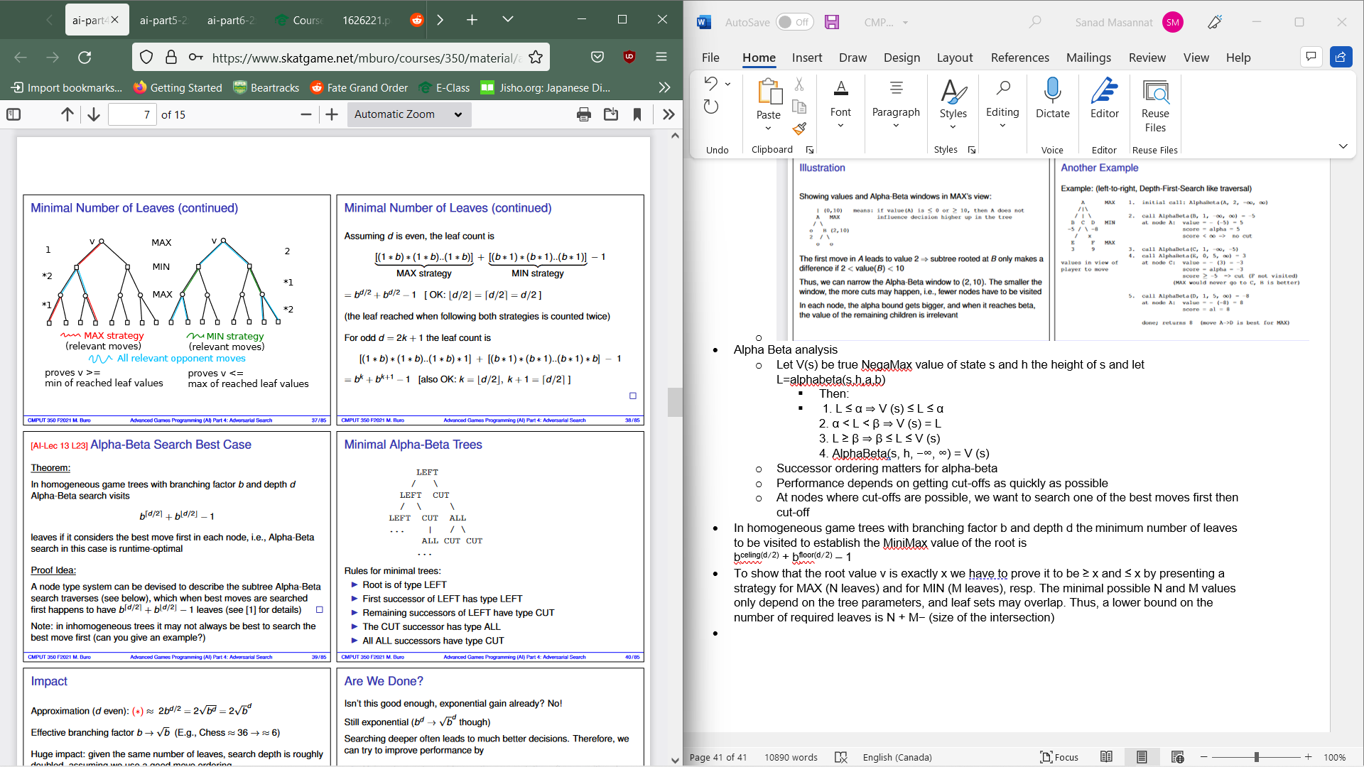
* Search is performed in directed Acrylic Graphs (DAG) or general directed graphs, often usedto detect and eliminate cycles while also directing transpositions to reduce search effort.
* A cycle is a path from root to current node which contains a repeated position and thus searching these is not productive
* These can easily occur in games with reversible/commutative moves
* Use a stack of states to detect cycles:
  + Make move 🡪 push, undo 🡪 pop
  + Before push, check if already in stack
* Optimize possible when irreversible moves are here
* Little storage yet slow
* Possible to reach same state in 2 different way and we want to detect and eliminate redundant searches.
* Keep history of previously visited nodes and not just the current search paths
* Transposition Table:
  + Cache of visited states and exact values, also has previously computed best moves. Done as hash tables due to speed
  + When visiting a node, we check the table if the state encountered at a height is greater than the current height and if so we reuse the stored value and possibly result in immediate backtracking by making a cut otherwise we search the subtree with the previous best move. Then save the result in the table(exponential)
  + Info we need when revising a state:
    - Best previously found move (m):
      * Try m first as it is usually also the best for the next search
    - Search result (v):
      * According to the Alpha-Beta Return Value Theorem, the previous result is either exact, a lower bound for the true state value, or an upper bound. To decide what to do when we reach the state a second time, we need to store v and a flag f that indicates the type of v
    - Search height (h)
      * If the tree can’t be traversed completely, heuristic evaluations need to be used and a deeper search can overcome deficiencies as they are more accurate. If we reach a state a second time via move transposition, remaining search height could be different. If <= , we can use stored v and f values else, we need to search again
    - Current (alpha, beta) window at the time we revisit a state influences decision of whether to re-traverse the subtree or not depending on v and type.
      * V is exact: return v immediately
      * V is a lower bound of true value. Since we know that the true state valis is >=v and subtree can only influence the decision at root if its value lines in (alpha, beta) . Both conditions can be taken into account by changing the search window leading to smaller searches and in the case of max(v, alpha)>= beta to a beta cut and return v as a lower bound.
      * V is an upper bound of true state value
      * In this case we know the true state value is ≤ v and, again, the subtree can only influence the decision at the root if its value lies in (α, β)  
        Both conditions can be combined by changing the search window to (α, min(v , β))  
        If min(v , β) ≤ α, we know the value cannot reach α, and we therefore can return v immediately, without further search  
        Otherwise, the search window may have narrowed which can save  
        time in the subsequent search
    - Code:
      * int AlphaBeta(State s, height, alpha, beta)  
        {  
        if (height == 0 || terminal(s)) {  
        return Value(s , toMove(s))  
        }  
        ttEntry ← checkTT(s, height, alpha, beta)  
        if (alpha ≥ beta) { return ttEntry.value }  
        score ← -∞  
        // try heuristically best move first  
        children ← GenerateAndSortChildren(s, ttEntry.bestMove)  
        for (i ← 0; i < children.size(); i++) {  
        value ← - AlphaBeta(children[i], height-1, -beta , -alpha)  
        if (value > score) {  
        bestMove ← move i  
        score ← value  
        if (score ≥ alpha) { alpha ← score }  
        if (score ≥ beta) { break } // beta cut  
        }  
        }  
        saveTT(ttEntry, s, score, bestMove, height, alpha, beta)  
        return score
      * // retrieves TT entry and adjusts alpha,beta according  
        // to stored value bounds  
        TTEntry checkTT(State s, height, ref alpha, ref beta)  
        {  
        ttEntry ← TranspositionTableLookup(s)  
        if (ttEntry.valid() && ttEntry.height >= height) {  
        // entry has been written to and stored value  
        // is result of deeper or equal height search  
        // which we trust to be at least as accurate  
        if (ttEntry.flag == EXACT) {  
        alpha ← beta ← ttEntry.value  
        } else if (ttEntry.flag == LOWERBOUND) {  
        alpha ← max(alpha, ttEntry.value)  
        } else if (ttEntry.flag == UPPERBOUND) {  
        beta ← min(beta, ttEntry.value)  
        }  
        }  
        return ttEntry  
        }
      * / save search results in TT entry  
        void saveTT(TTEntry ref ttEntry, score, bestMove, height, alpha, beta)  
        {  
        ttEntry.value ← score  
        ttEntry.bestMove ← bestMove  
        ttEntry.height ← height  
        // using the Alpha-Beta return value theorem:  
        // score ≥ beta => true state value ≥ score  
        // score ≤ alpha => true state value ≤ score  
        // otherwise, true state value = score  
        if (score ≤ alpha) {  
        ttEntry.flag ← UPPERBOUND  
        } else if (score ≥ beta) {  
        ttEntry.flag ← LOWERBOUND  
        } else {  
        ttEntry.flag ← EXACT  
        }
  + Useful for move sorting when using iterative deepening
    - h = 0  
      while (have time) {  
      // using TT for storing values and best moves  
      v = AlphaBeta(s, h, -∞, ∞)  
      ++h  
      }
  + Faster than going to max height immediately as best moves in previous iteration are most likely to be good in next iteration so we store in TT and try them first and improve alpha-beta search
  + 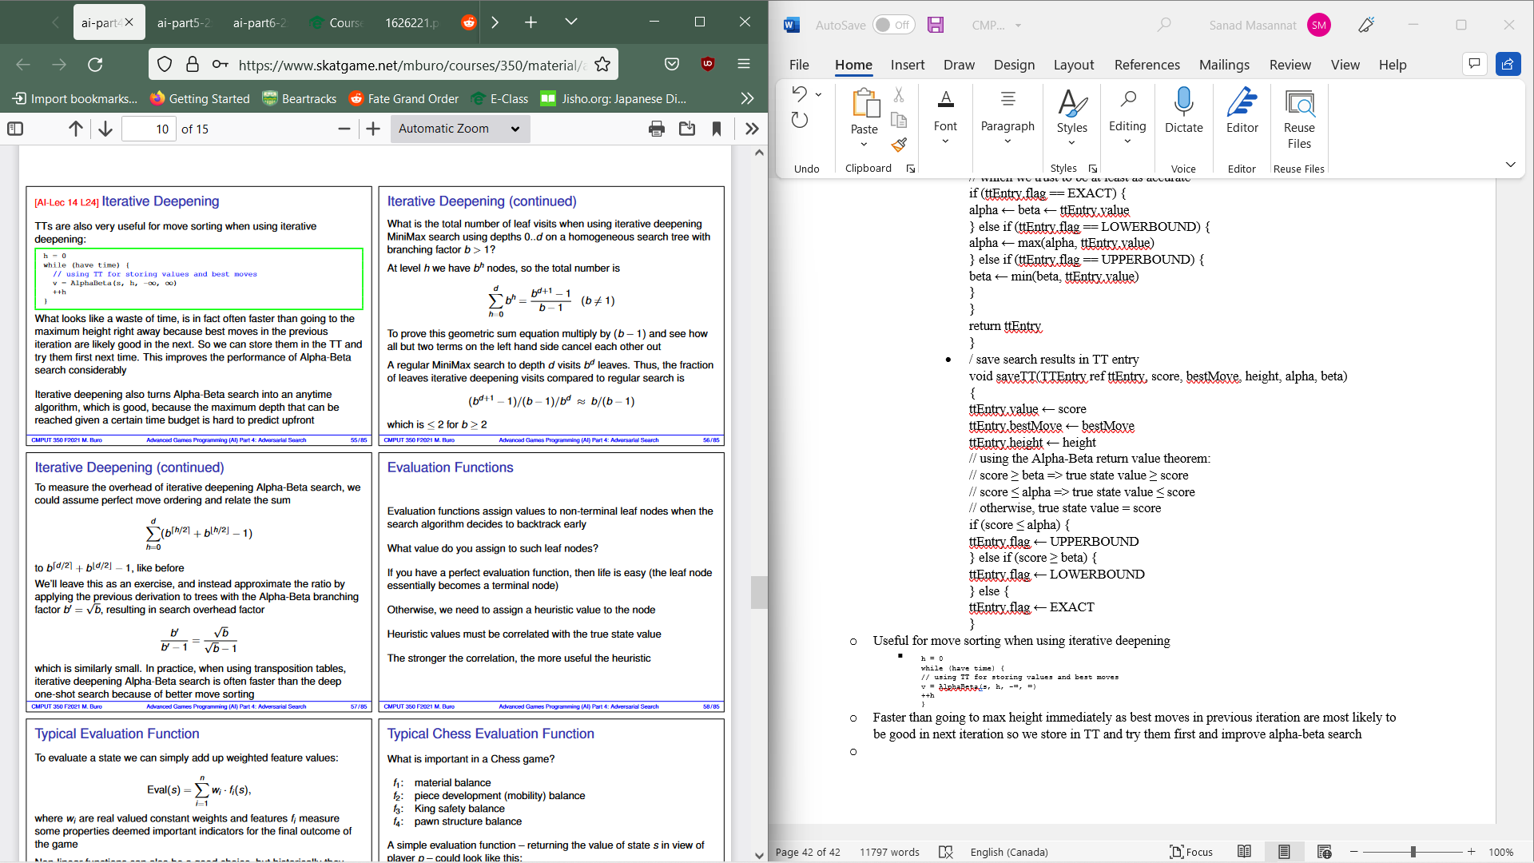
  + 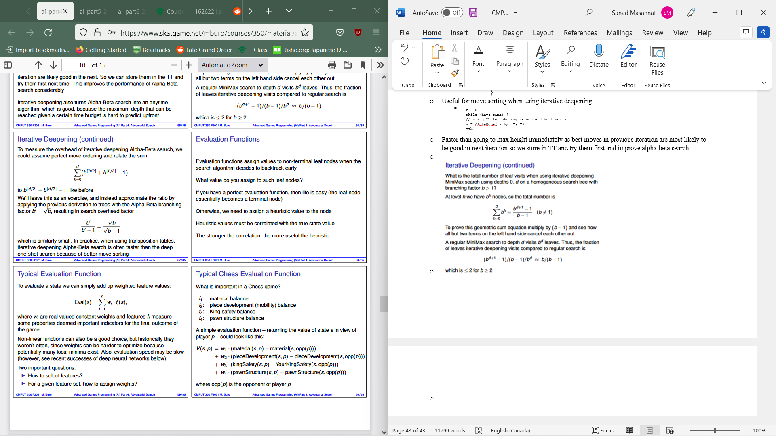
* Evaluation functions assign values to non-terminal leaf nodes when search alg decides to backtrack early
  + If perfect evaluation function, leaf=terminal node otherwise we need to give node a heuristic value
  + 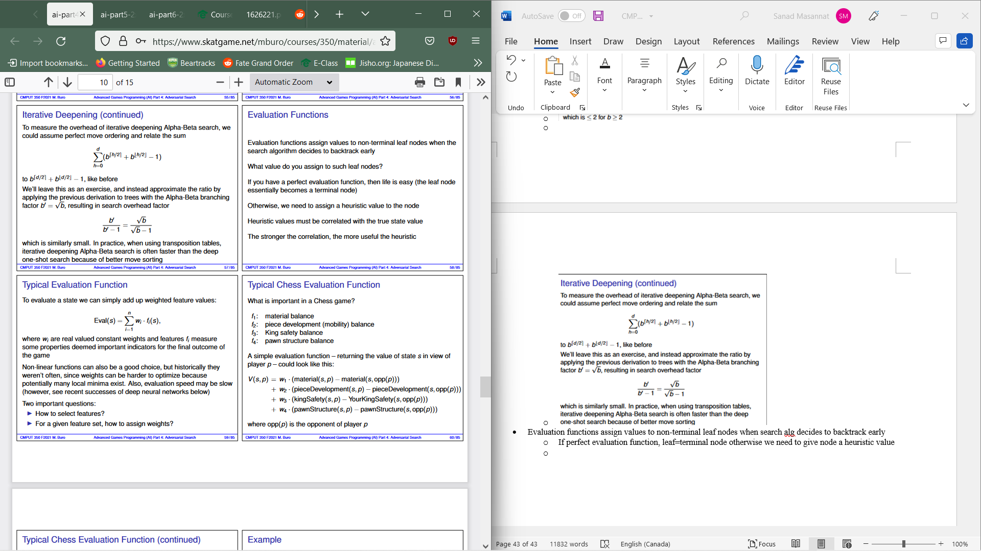
  + 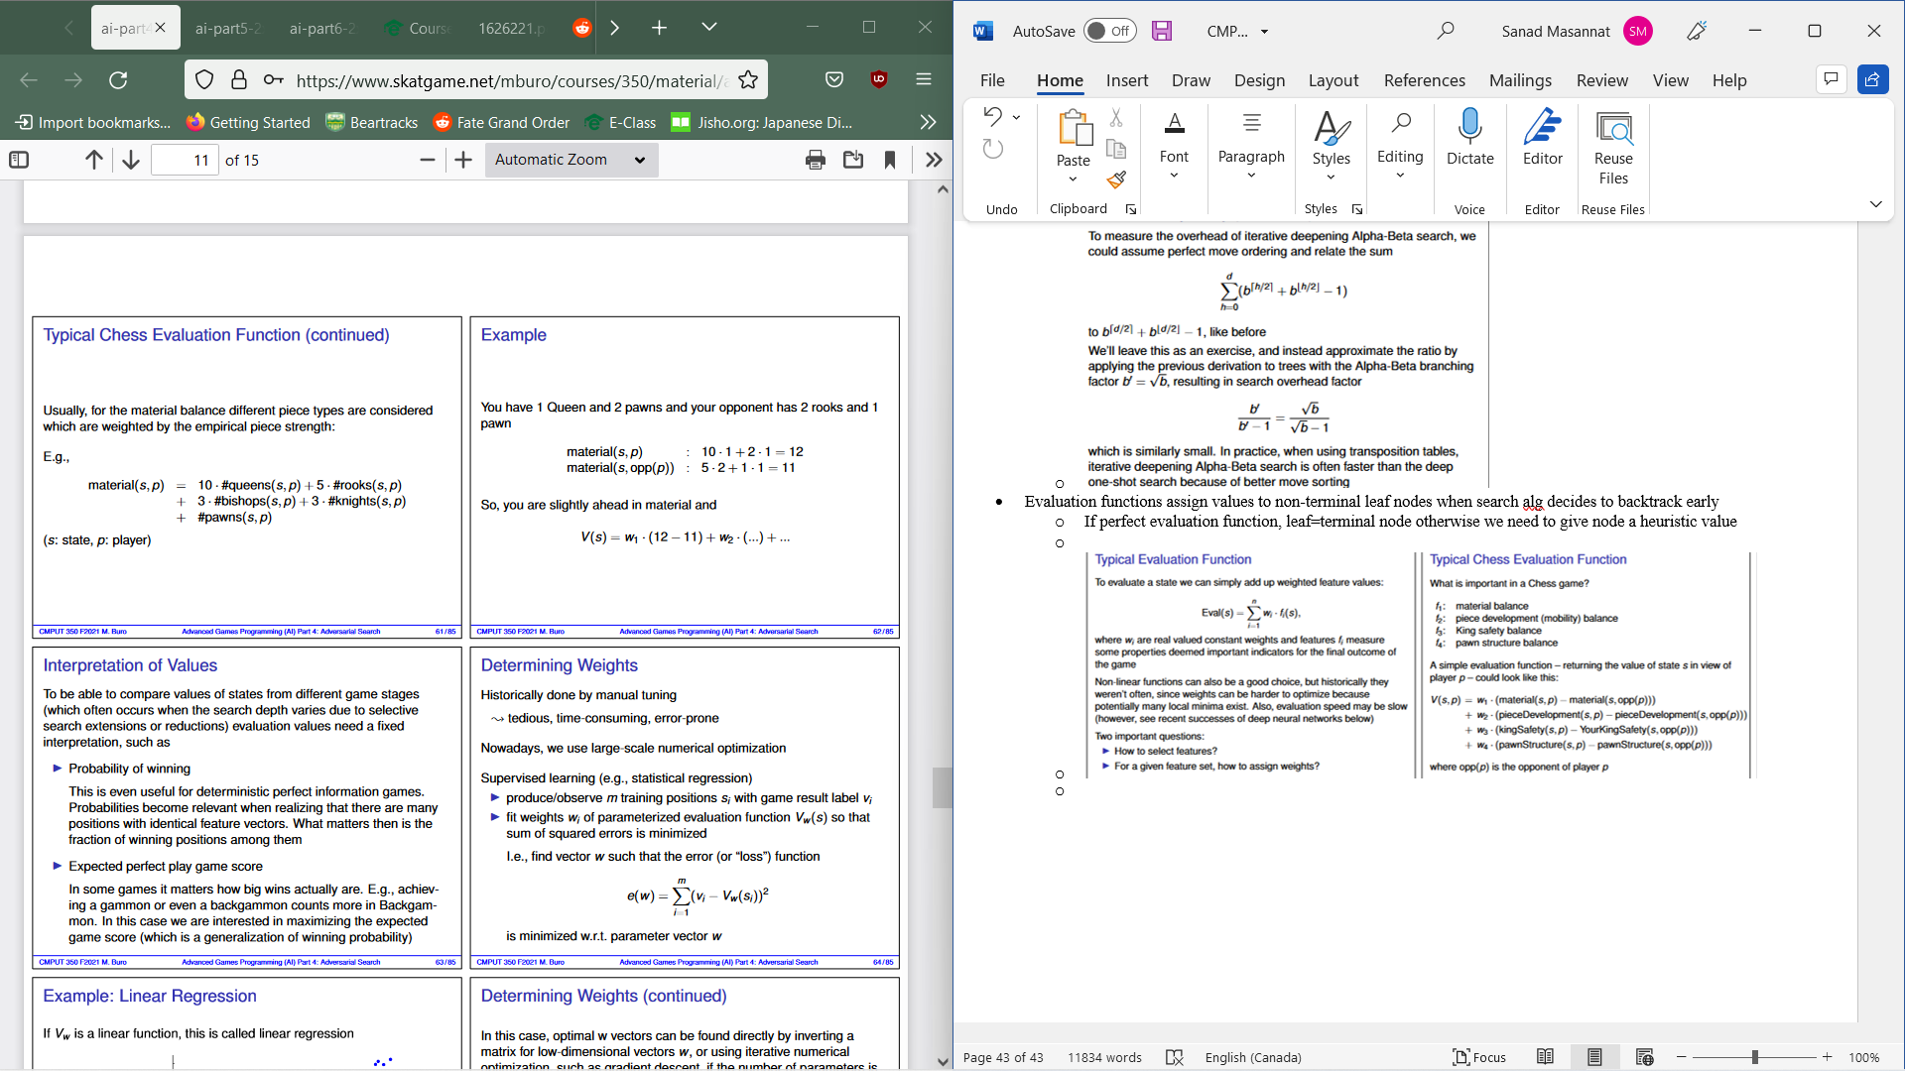
* To compare values of states from different game stages, evaluation values need a fixed interpretation:
  + Probability of winning: useful for deterministic perfect info games and are relevant as there are many positions with identical feature vectors.
  + Expected perfect play score: How big wins are can be important to some games
* To determine weights, use large scale numerical operation
* Supervised learning is used
  + Produce/observe m training positions si with game result label vi
  + Fit weights wi of parameterized evaluation function Vw(s) so sum of squared errors is min
  + 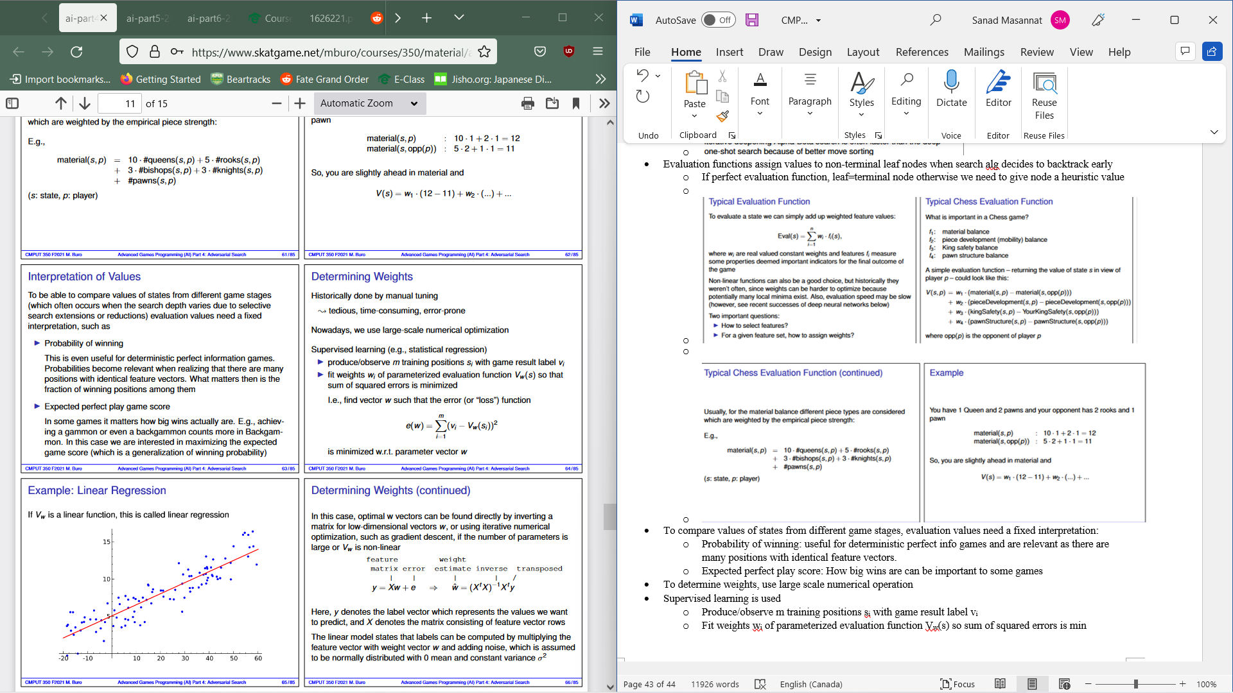
  + 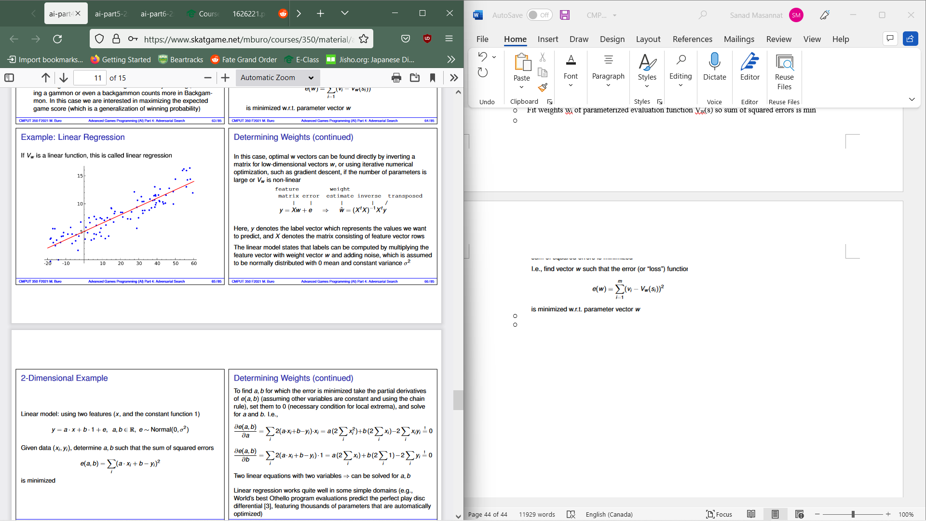
  + 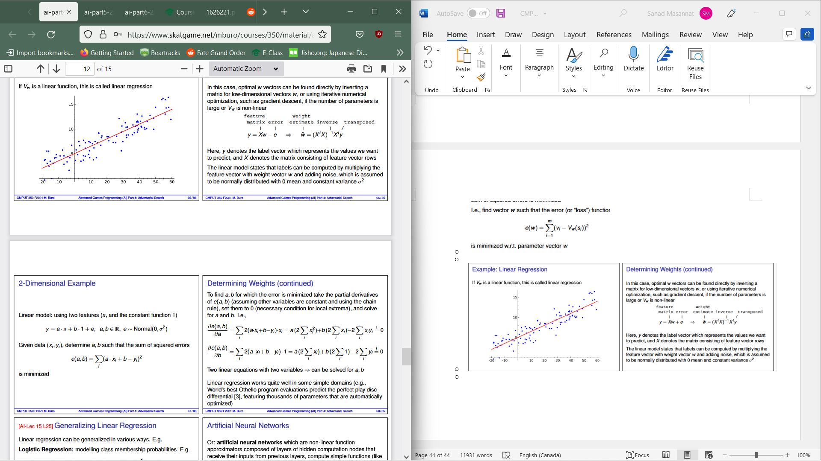
  + 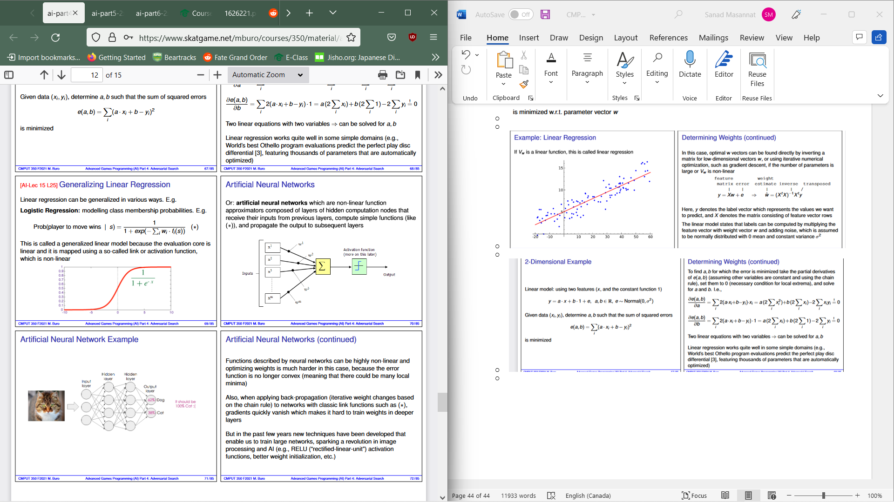
  + 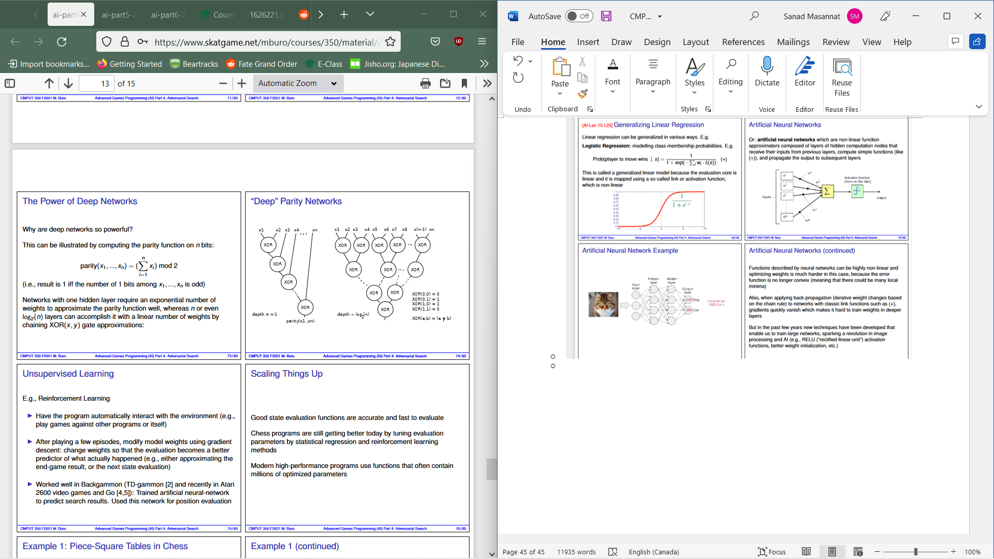
  + Best known category of constrained optimization problem is linear programming(LP) which constraints must be linear inequalities which represent half-spaces whose interaction forms a convex set and objective function is also linear
  + Simplex Algorithm hops from corner to corner to find optimal solution (worst case is exponential time).
  + LPs are a special case of more general convex optimizations which allows constraint region to be a convex region and objective to be any function that is convex within constraint region
* Matrix Games:
  + 2 players and two payoff matrices.
  + Simultaneous moves(player 1 gets row and player 2 picks column
  + Payout is Aij for 1 and Bij for 2
  + Total is 0 for payout matrix
* MiniMax Theorem: for every 2 player zero sum game with finite pure strategies, tere I a value V and a mixed strategy such that
  + Given MINs strategy, best payout for MAX is V and
  + Given MAXs strategy, best payout for MIN is -V
* Generally: It is a tuple of strategies which form a Nash equilibrium if no unilateral strategy deviation beneficial to a single player exists.
* A mixed strategy is a probability distribution over all player’s choices
* If MAX picks row I and Min picks column j, result is Aij given that MAX uses strategy x(picks row i) and MIN uses strategy y (picks column j) with a probability of xi*yj. Thus expected result is Aij* xi*yj
* Sum of all choice pairs for MAX gives us the payoff xTA*y
* Strat x is a best strat for MAX for fixed y if it maximizes xT(A*y) whereas for fixed x, best response start for Min minimizes (xTA)*y
* Best response value for max given y: max xT(A*y) subject t sum of xi =1 and xi>=0 for all i
* Constraint means x is a probability distribution where MIN tires to minimize MAX’s value and vice versa
* MiniMax Theorem: min max xT (A*y)=max min (xTA)*y . Note this is not an LP but min (xTA)*y for a given strat x can be achieved by pure strategy y
* 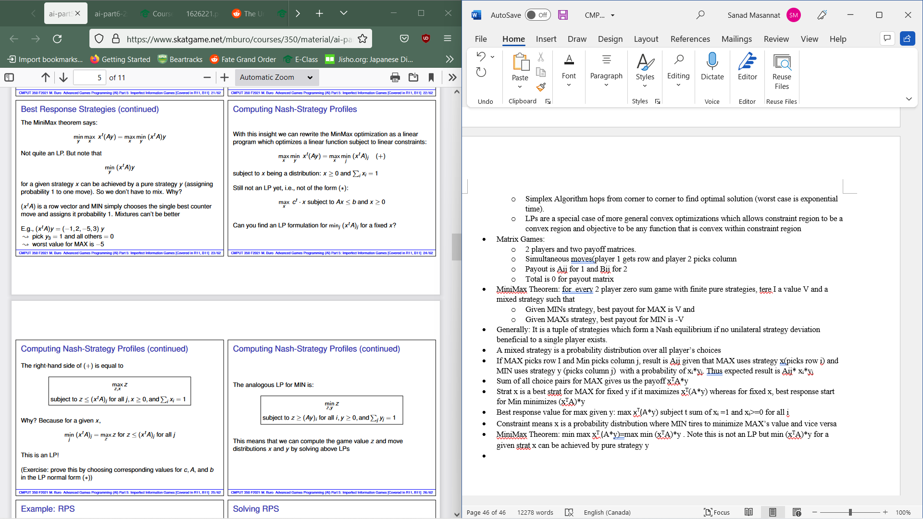
* 
* Extensive form game representation consists of a game tree and info set overlay
* Perfect Info Case:
  + Overlay both trees 🡪 principal Variation🡪 Leaf value determines payoff
* Imperfect info case:
  + Create payoff matrix where a move is now pure strategy where payoff entry I,j is value of pitting strategy I vs j. Where mixed minimax strategy = mixture of pure strategy.
* Distributions can be computed by solving LPs.
* # of strategies usually exponential in game tree size
* N vs m unis with attack value and hitpoints and assume every unit can attack all others, playing in rounds until one is defeated. Matrix game info:
  + Row/columns: which units do both players attack
  + Entry: Expected value of reached state when attack action I, j are chosen
* Tree of matrix games can be solved bottom up by LP by solving leaf state LPs and use their values in payoff matrix entries one level up.
* Minimax in RTS at lowest level will not work.
  + Moves=strategy
  + Computing Move= selecting strat
  + During game, create payoff matrix with results of I vs j
  + Solve Lp🡪strat distribution
  + Pick strat accordingly the replan
  + Issues:
    - Slow and matrix to be filled
    - Simulate till the end
    - Choice Points would be nice
    - Partial observability
    - Opponent strat could not be covered
    - Nash equilibria doesn’t maximally exploit
    - Payoff entries may be random values
* For state/action abstractions, we need to consider unit groups and strategies issue group commands
* Matrix Computation:
  + for (int i=0; i < numOurStrategies; ++i) {  
    for (int j=0; j < numTheirStrategies; ++j) {  
    if (!nextSimulationAllowed())  
    return notDone  
    r[i][j] = simulate(ourStrat[i], theirStrat[j])  
    }  
    }  
    return pickStrategy(r)
* When opponent modelling, monitor opponents actions, only consider opponent strats and if no strategy matches consider all strategies
* When using Nash equilibrium, player who uses it is not expected to win if value is 0.
* Sampling-Based Decision making:
  + For each move choice at root node, we gather samples and compute performance matrix and repeat till exhausted resources. We then choose move with best statistical outcome.
  + Usually sample till time runs out or statistically confident
* Selective Sampling is used when we don’t want uniform random sequences.
* Sample Based Search
  + Pros:
    - Conceptionally a simple search algorithm  
      Can realize complex behaviors with no explicit knowledge🡪lessens dependence on expert knowledge  
      Prefers robust positions with many winning continuations
  + Cons:
    - Problems in tactical situations
      * Narrow lines of play are hard to find by randomized search
      * May not converge to a winning move at all – if one exists
      * Or may not converge to a clear ’winner’
      * Doesn’t approximate mixed strategies out of the box (i.e., compute  
        move probabilities),  
        To get useful results may need to include opponent modeling  
        Observe opponents to determine their likely move choices opponent modeling is a hard problem!
* MCTS(Monte Carlo Tree Search)
  + Iterative search framework in which it maintains a tree of visited game states and results that determine next move
  + Selection🡪Expansion🡪Sampling🡪Backpropagation
  + Selection: Start from root R and select successive child nodes down to a leaf L and choose nodes which let tree expand toward most promising regions
  + Expansion: unless L ends the game with a win/loss, create 1+ child node and choose from node C
  + Sampling: rollout (starting from C, finish the game randomly)
  + Backpropagation: Use rollout result to update info in nodes on the path from C to R
* UCT(upper confidence Bound for Trees):
  + Sampling based method for game tree search
  + Regret: How much we lose while experimenting compared to playing best move from start
  + UCB(upper confident Bound) :Given n slot machines with random rewards Xi ∈ [0, 1], find the machine with the highest expected value, while minimizing the regret, by pulling arms
  + Solves exploration-exploitation problem
  + Xi = average reward for i-th arm thus far
  + Ti= number of trials for arm i
  + T=number of Trials
  + 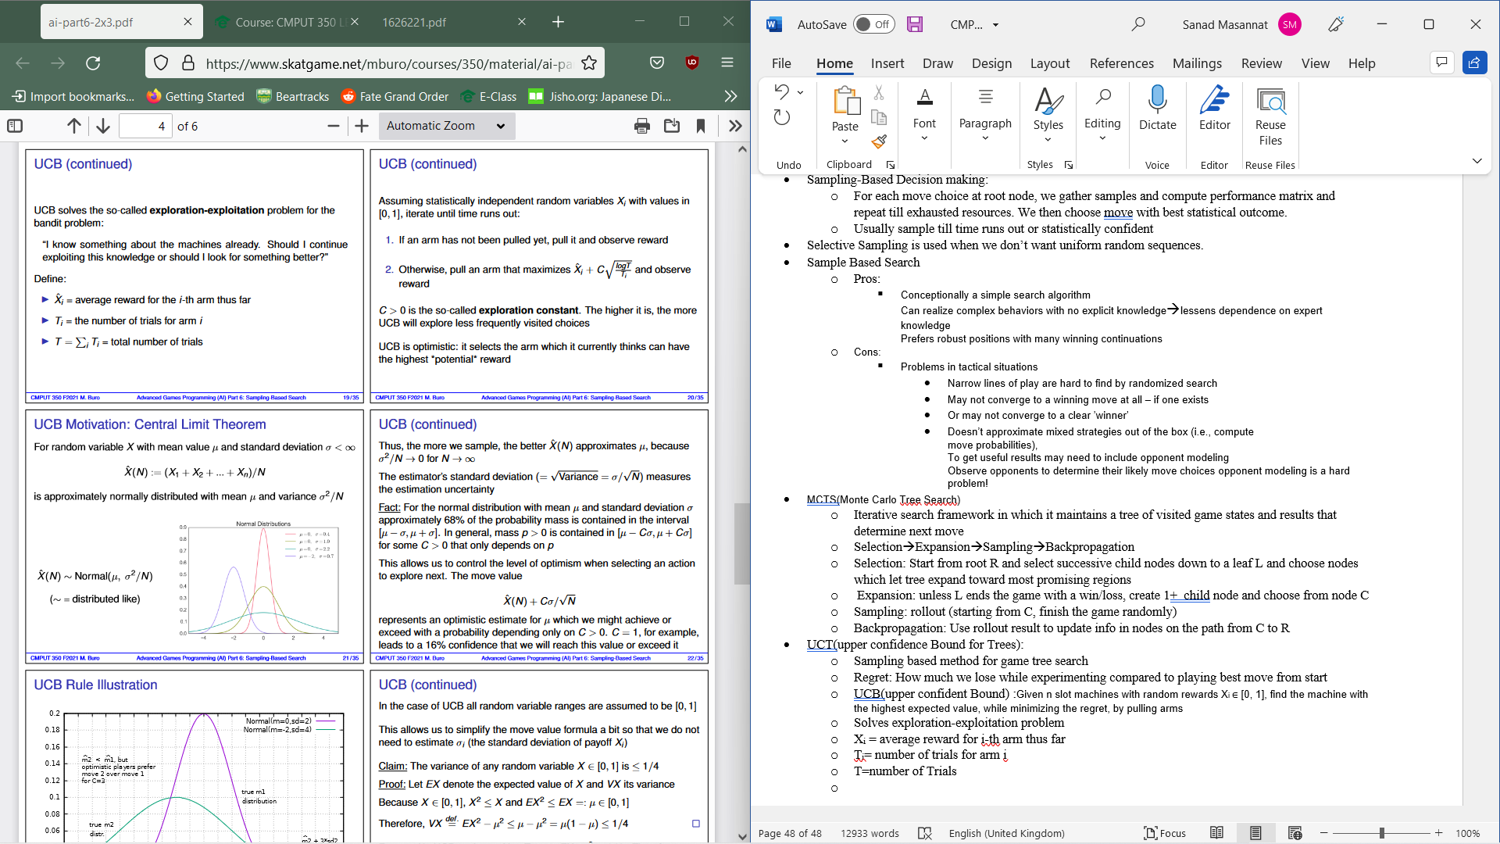
  + 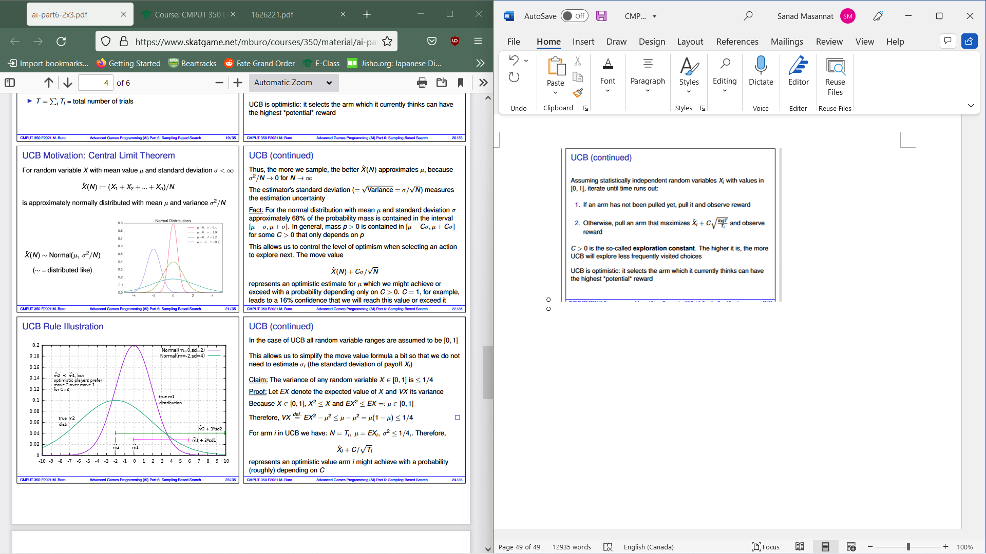
  + 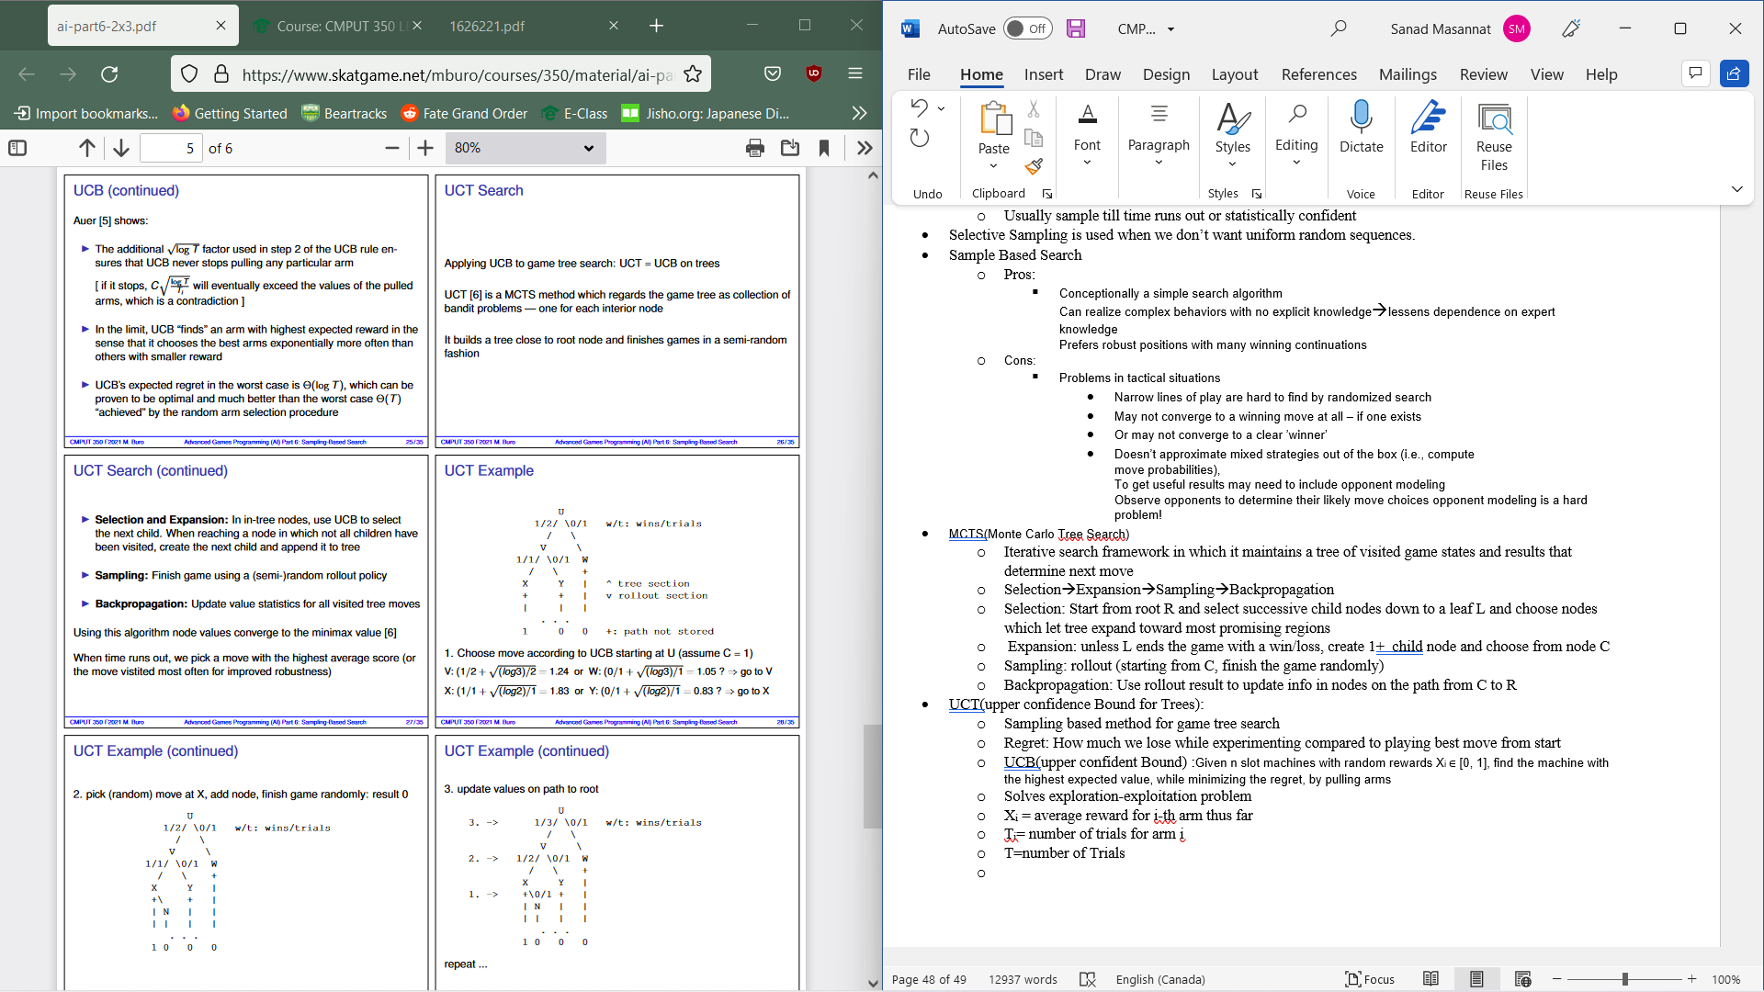
  + Rapid Action Value Estimation : In games with transpositions it is often the case that values of moves played now or a bit later are highly correlated and UCT can take advantage of this by maintaining statistics for unseen stats for unseen moves based in their performance
  + Prior Knowledge; original UCB requires us to pull each arm once and an be wasteful in games especially if chance if visiting a bode again is low.